BizTalk 2009 Installation and Configuration Guide - Production Build v1.3
BizTalk 2009 64-bit, SQL Server 2008 SP1 64-bit, Windows 2008 R2 64-bit(Production Build, no Visual Studio or Developer Tools)_v1.3
Jay Kladiva
Energizer Holdings, Inc.
MCSE, MCSD, MCAD .NET, MCT, MCP + Site Builder
3/15/2010
This is a complete Installation and Configuration guide for BizTalk 2009 that documents all the steps necessary from start to finish to setup a BizTalk Server environment. This was built on a Hyper-V R2 image that only contained one .vhd file so everything is installed on the C:\ drive. In production you would usually want to install BizTalk Server on one machine and SQL Server on another machine. The steps would be the same as outlined in this document except you would install SQL Server on a remote server as listed in Section 2.6. The only other considerations would be to perform the steps listed in 2.13 and 2.14 prior to installing SQL Server on the remote machine to ensure proper communication. All other software and configuration is done on your primary BizTalk Server. If you plan to have multiple BizTalk Server in your BizTalk Server Group, first build out your first BizTalk Server, then follow the same steps to build the next BizTalk Server excluding installing SQL Server, SQL Notifications, and setting up domain accounts. When you get to Step 2.18 on the Enterprise SSO and BizTalk Group sections select ‘Join a BizTalk Server……’ instead of ‘Create New…….’ which will have your secondary BizTalk Server join the existing BizTalk Server Group and will allow it to pull the settings which are stored in the BizTalk databases to configure this server. The rest should be self explanatory. If you install BizTalk on more than one BizTalk Server then I recommend moving your Master Secret Server to the remote SQL Server. If BizTalk losses connectivity to the SQL Server it will fail and this eliminates the issue of having the non-primary BizTalk Servers fail due to failure of the primary BizTalk Server because it acts as the Master Secret Server as well. The secondary BizTalk Servers act as backup Master Secret Servers and cache the secret but if the servers reboot and the Master Secret Server is not available then all the secondary BizTalk Servers will be rendered useless. All software was installed using the ‘Developer Edition’ for the purposes of drafting this document, in production you need to install ‘Standard Edition’, ‘Enterprise Edition’, or one of the other versions that supports your needs. Finally, I recommend having separate domain accounts for Development/Test and Production. All non-Production servers should use domain accounts with the ‘_T’ appended on the end of the account name, for this document I used ‘Test’ accounts but if you are building out a true production environment then you would not use the ‘Test’ accounts.

Table of Contents
1. Document Information 4
1.1. Revision History 4
1.2. Reviewers and Sign-off 4
1.3. References 4
2. BizTalk 2009 64-bit Installation & Configuration Guide 5
2.1. Pre-requisites 5
2.2. Pre-Installation 5
2.3. Add and Configure the Web Server (IIS) and Application Server Roles 6
2.4. Install SQL Server 2008 64-bit 15
2.5. Install SQL Server 2008 SP1 64-bit 34
2.6. Install SQL Notifications Services 40
2.7. Windows SharePoint Services 3.0 x64 with Service Pack 2 51
2.8. Disable the Shared Memory Protocol 70
2.9. Join the Local Administrators Group 71
2.10. Configure the Application Event Log 71
2.11. Enable TCP/IP and Named Pipes 72
2.12. Enable DTC on the Local Host Server 73
2.13. BizTalk Server 2009 64-bit Installation 76
2.14. Verify Your BizTalk Server 2009 Installation 82
2.15. Setup Domain Accounts For BizTalk Server 2009 83
2.16. Configure BizTalk Server 2009 85
2.17. Configure BizTalk Server SQL Jobs 108
2.18. Backing Up Custom BizTalk Databases 115

Document Information

Revision History
Revision | Description | Revised By | Revised on
v0.1 | Original Version | Jay Kladiva | 03/17/2010
v1.1 |  | Jay Kladiva | 03/30/2010
v1.3 |  | Jay Kladiva | 04/13/2010

Reviewers and Sign-off
Name | Role | Sign-off comments

References
Name of Document | Link/Location

BizTalk 2009 64-bit Installation & Configuration Guide

Pre-requisites
Install the hotfixes and patches via Windows Update.

Pre-Installation
Install the following programs to aid in installing the BizTalk platform:
- Install VirtualCloneDrive or some program to allow you to work with DVD .iso images
- Control Panel, ‘Folder Options’, ‘View’, remove checkmark for ‘Hide extensions for known file types’
- Install Microsoft Office 2007
    - Excel
    - InfoPath

Add and Configure the Web Server (IIS) and Application Server Roles
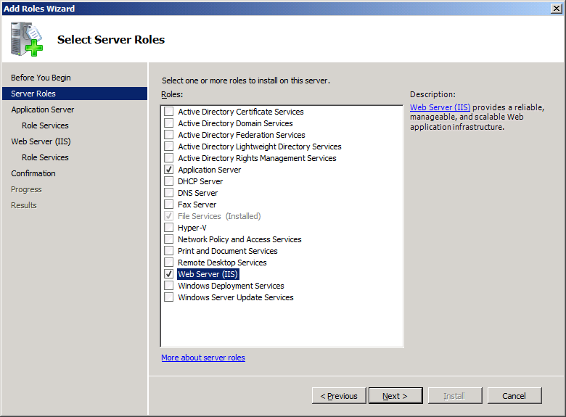
Check the Web Server and Application Server roles and click ‘Next’
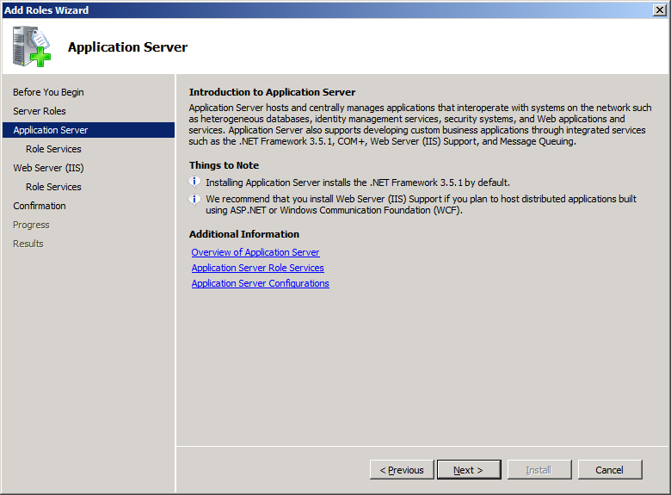
Read the notes and then click ‘Next’
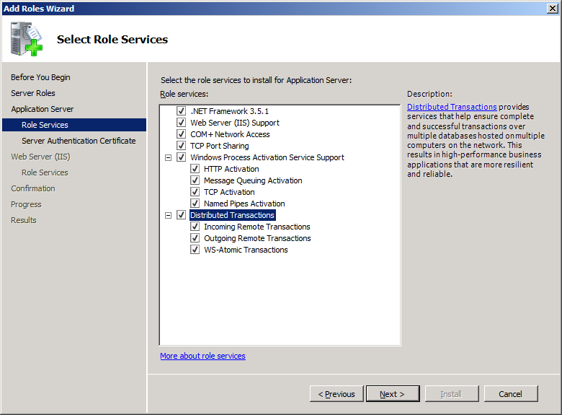
Check the options you want and click ‘Next’.

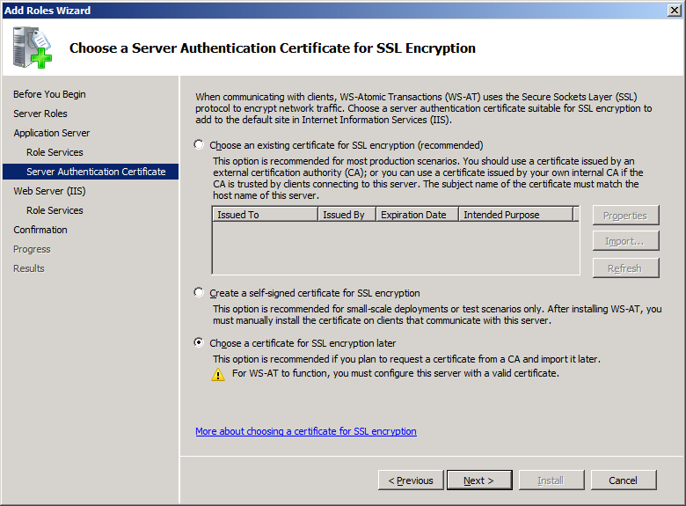
Select ‘Choose a certificate for SSL encryption later’ and then click ‘Next’. You can always configure WS-Atomic Transactions at a later point in time.

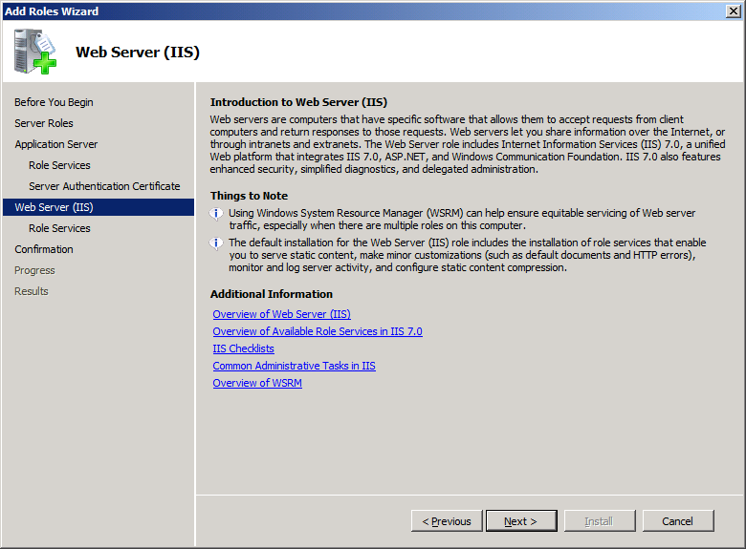
Need the notes and then click ‘Next’

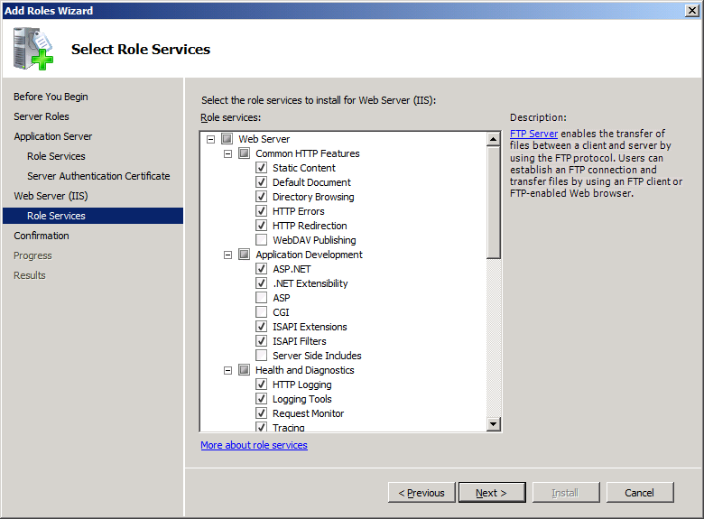
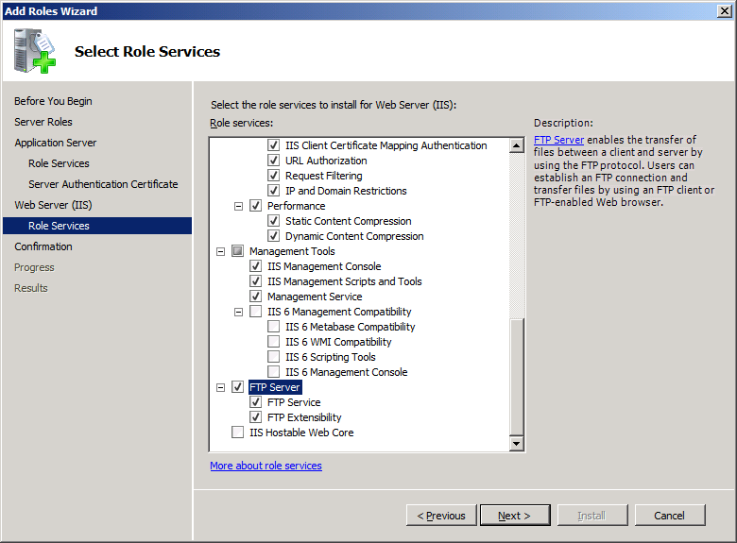
Choose the options you need, you probably want to select the ‘Common HTTP Features’ and the ‘Health and Diagnostics’

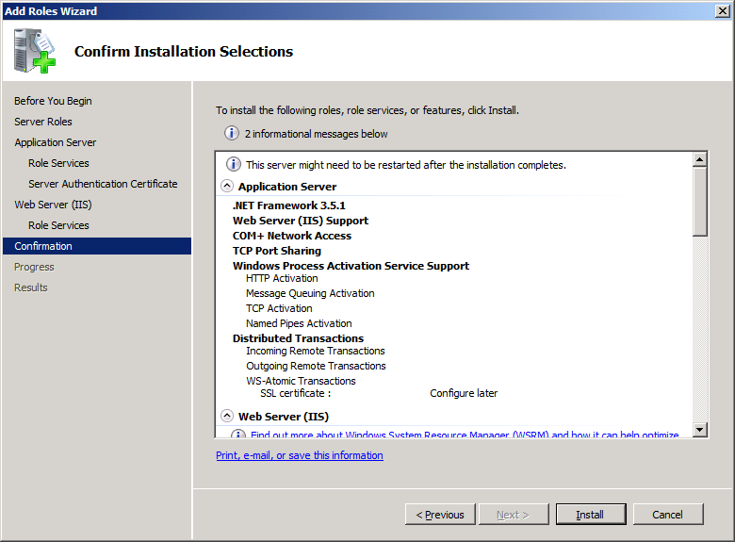
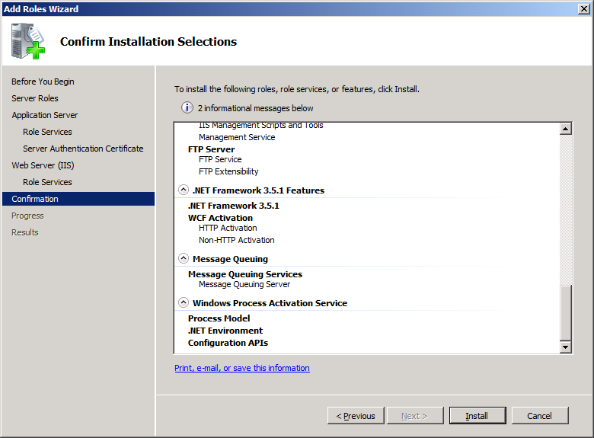
Review what is being installed and any information, warning, or error messages. You should not have any error messages, if so then you need to address them. Click ‘Install’

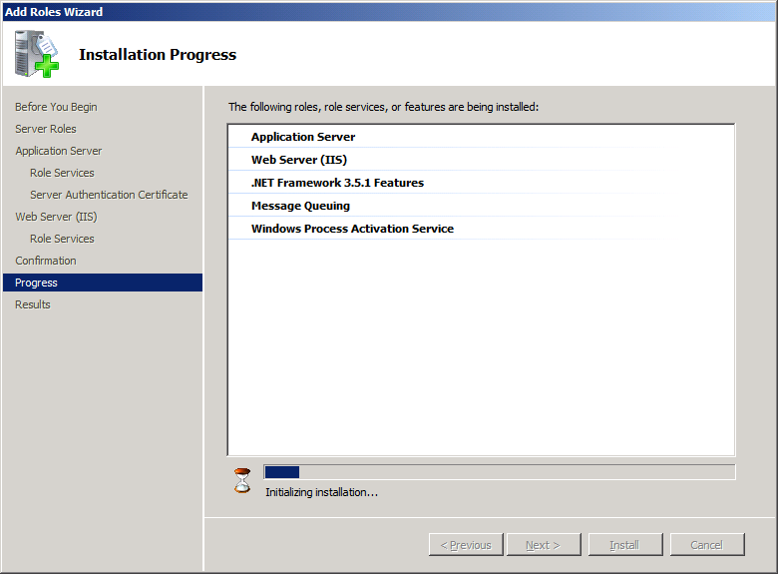
Installing

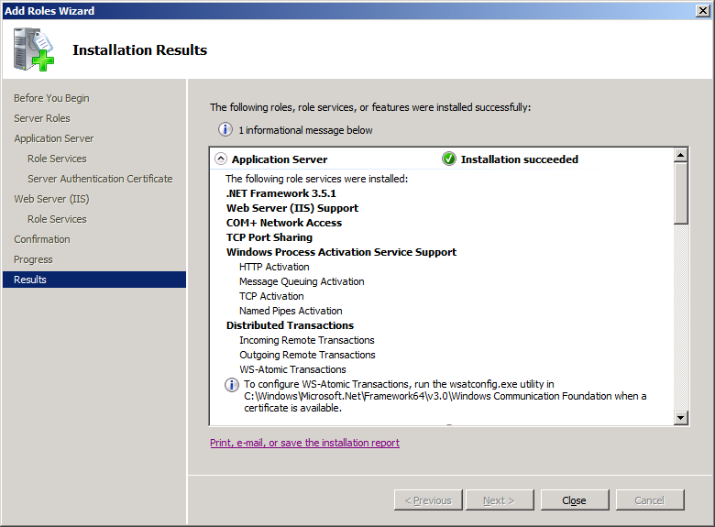
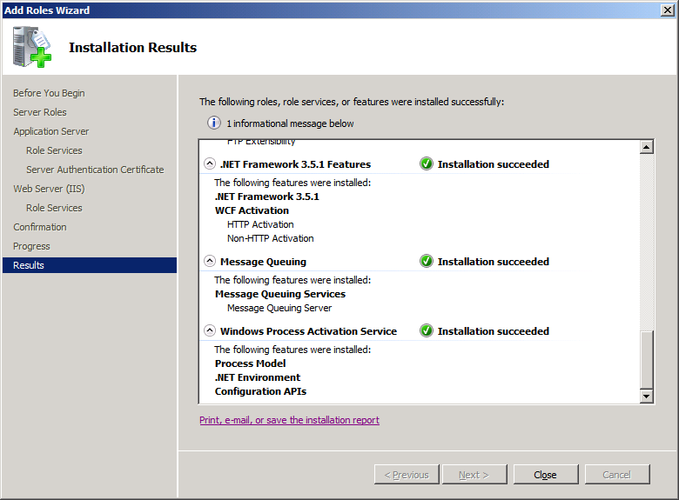
Review any messages, above the information message is ‘ To configure WS-Atomic Transactions, run the wsatconfig.exe utility in C:\Windows\Microsoft.Net\Framework64\v3.0\Windows Communication Foundation when a certificate is available.’ This adds a tab on the MS-DTC to allow you to configure WS-AT.
NOTE: Since this is a production build, Visual Studio 2008 SP1 is not required, only .NET 3.5 SP1 and .NET 3.0

Install SQL Server 2008 64-bit
Install SQL Server 2008 64-bit
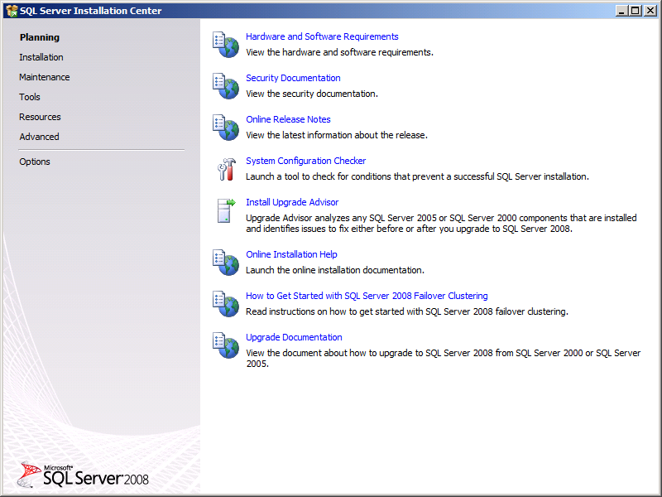
Click the ‘Installation’ link

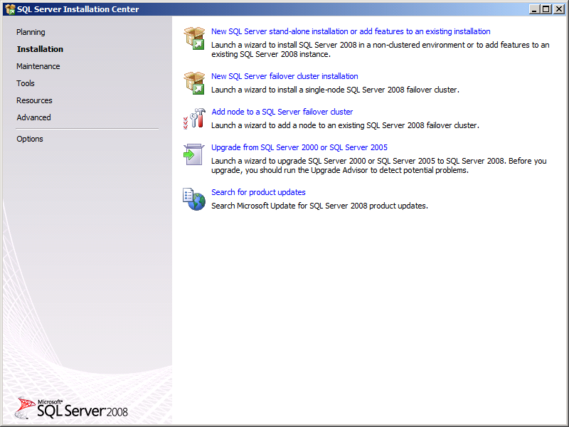
Click on ‘New SQL Server stand-alone installation or add features to an existing installation’ link
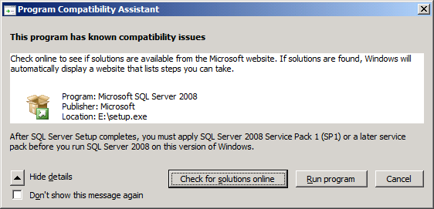
Ignore, this will be fixed by SP1, click ‘Run program’
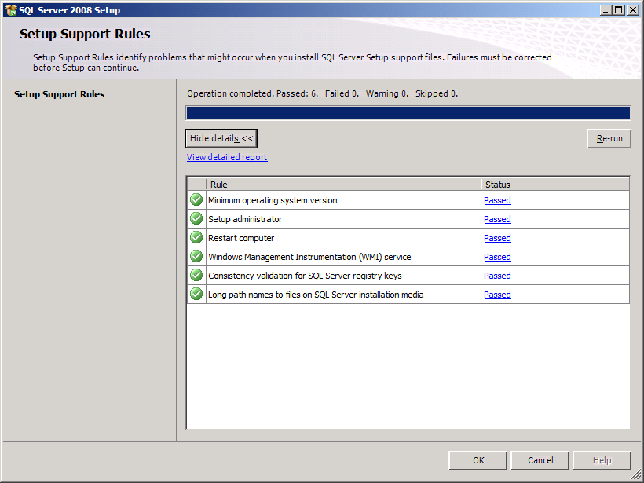
You want all green check boxes, click ‘OK’

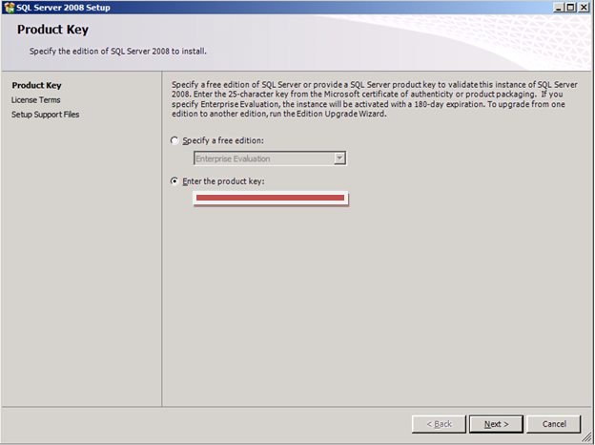
Enter product key and click ‘Next’
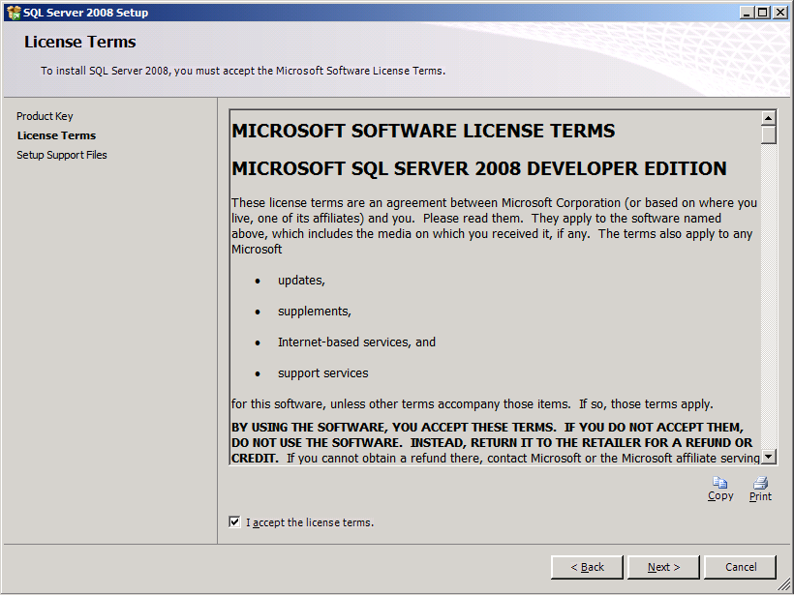
Accept the terms and click ‘Next’
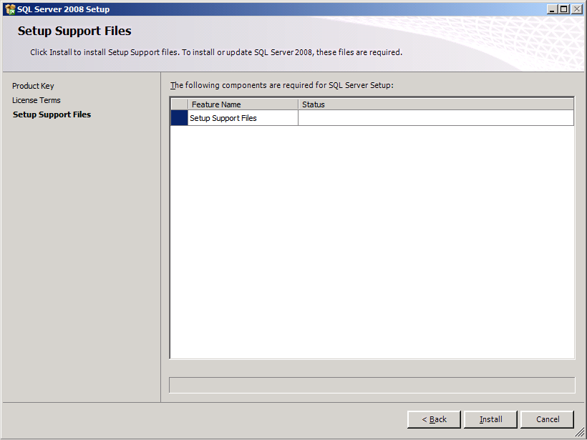
Click ‘Install’
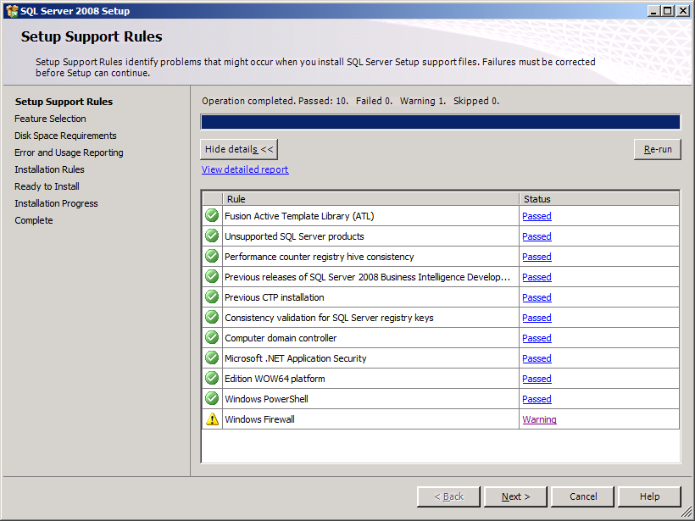
Review the results, you want all green check marks. In my case I had a Windows Firewall warning, see below:
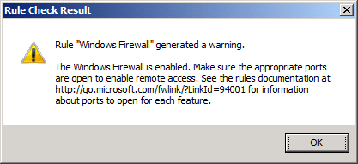
Click ‘OK’ and then ‘Next’ on ‘Setup Support Rules’ window
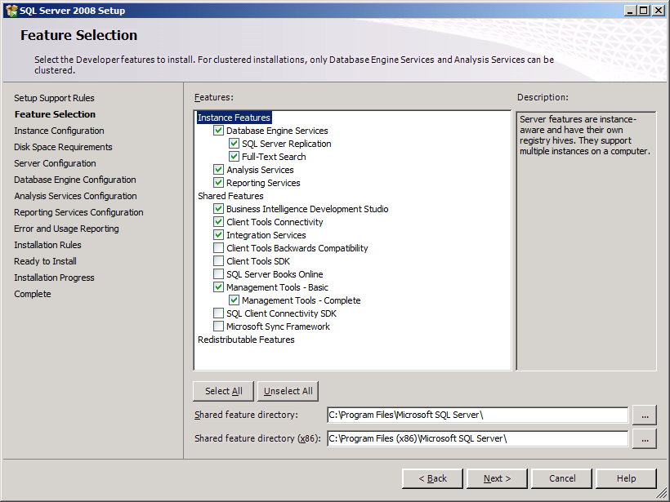
Select the options listed above and click ‘Next’
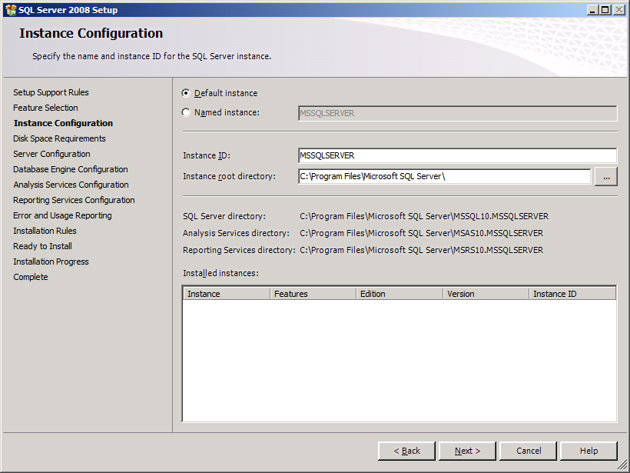
Select ‘Default instance’ and click ‘Next’. I’m building this BizTalk environment on my laptop using Hyper-V R2, ideally you should change the ‘Instance root directory’ to the D:\ or non-system drive. Otherwise your databases or backups could fill up the C:\ drive.
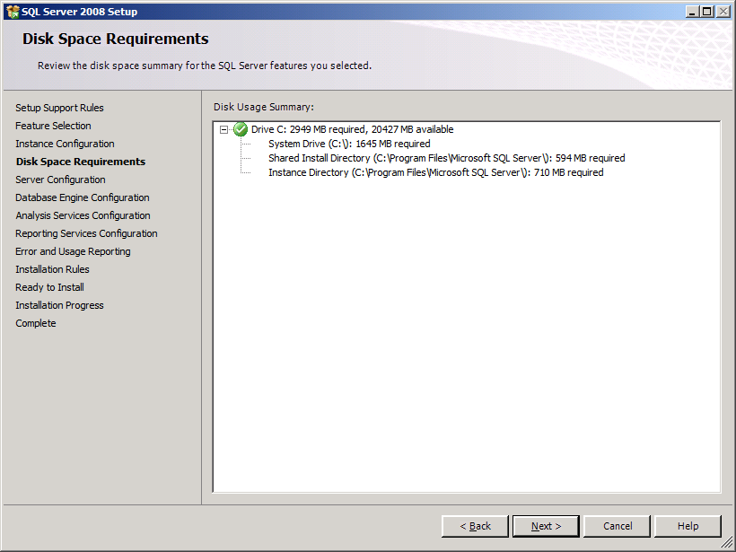
Review and click ‘Next’
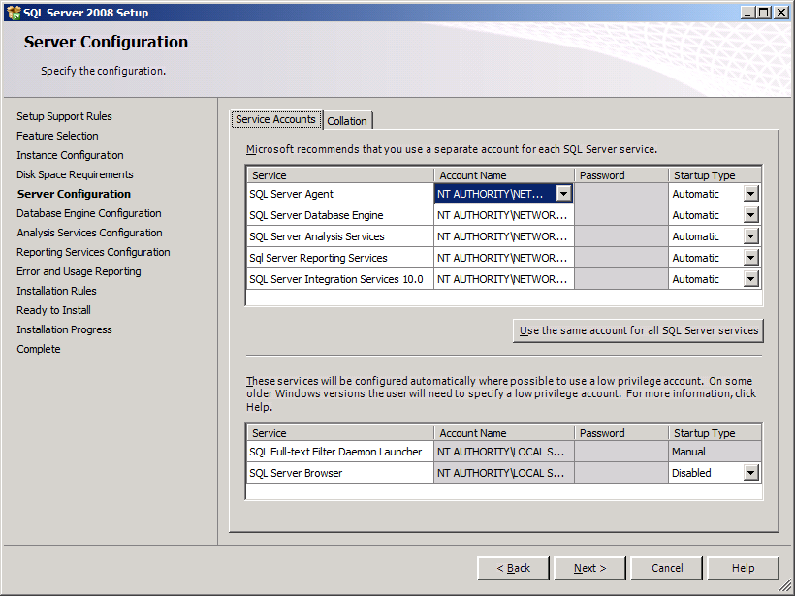
Set SQL Server Agent to ‘Automatic’, select ‘Use the same account for all SQL Server services’, and use the built-in Network Service account for the first 5 services listed above. Review and then click ‘Next’
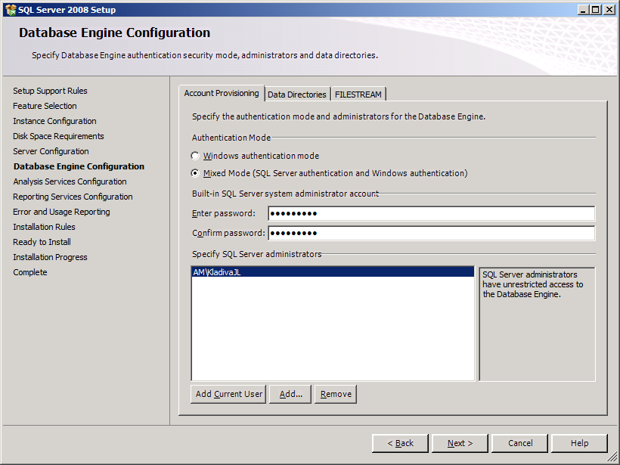
Select ‘Mixed Mode’ and leave the rest to the default. Add the current user as SQL Server admin and set the ‘sa’ password. On the ‘Data Directories’ tab you might want to change the location and select a non-system drive.
Password: <PASSWORD>
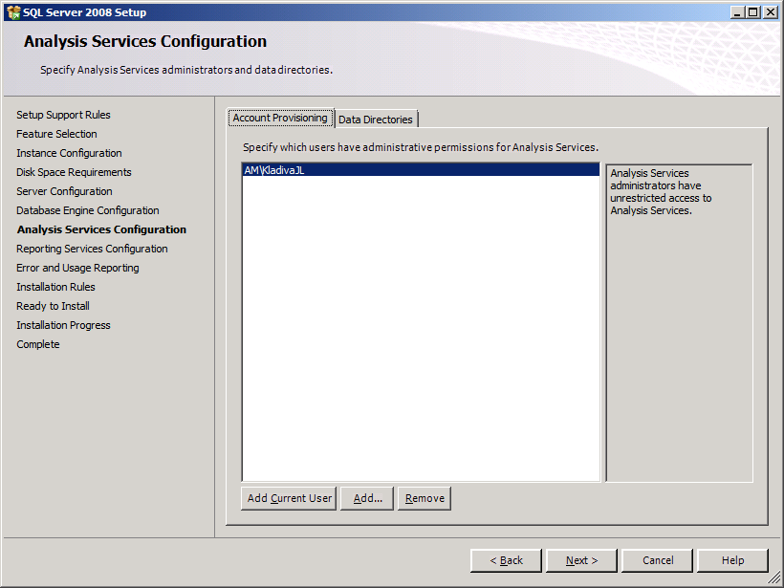
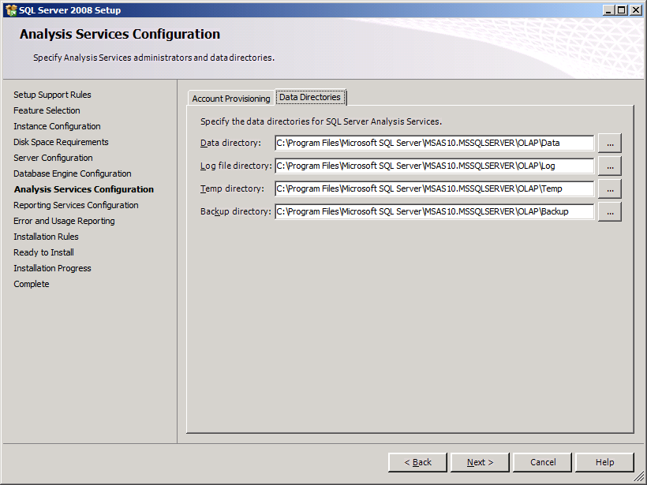
Add the current user and change the default locations on the ‘Data Directories’ tab to a non-system drive. I’m building a Hyper-V R2 image on my laptop and only have one .vhd setup so I’m installing everything on the C:\ drive. Review settings and click ‘Next’

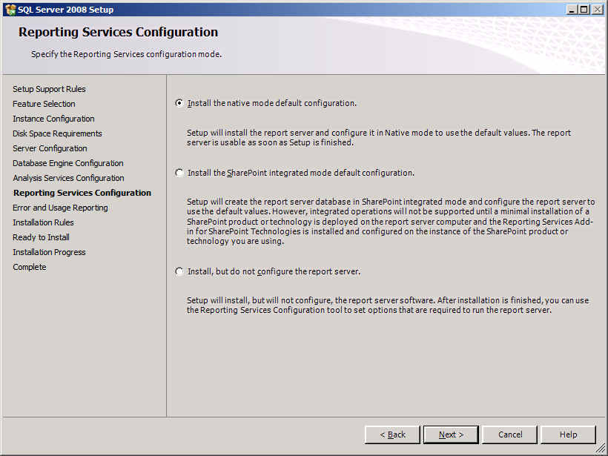
Select the ‘Install the native mode default configuration’ and click ‘Next’
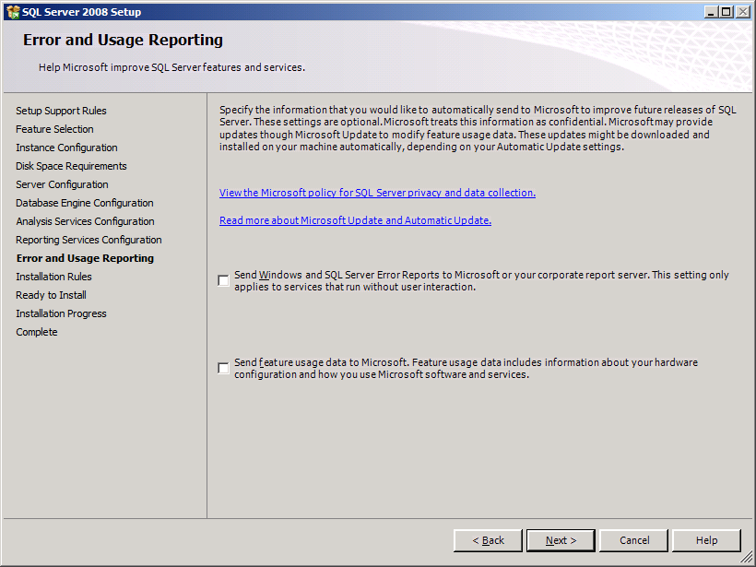
Uncheck the 2 boxes and click ‘Next’

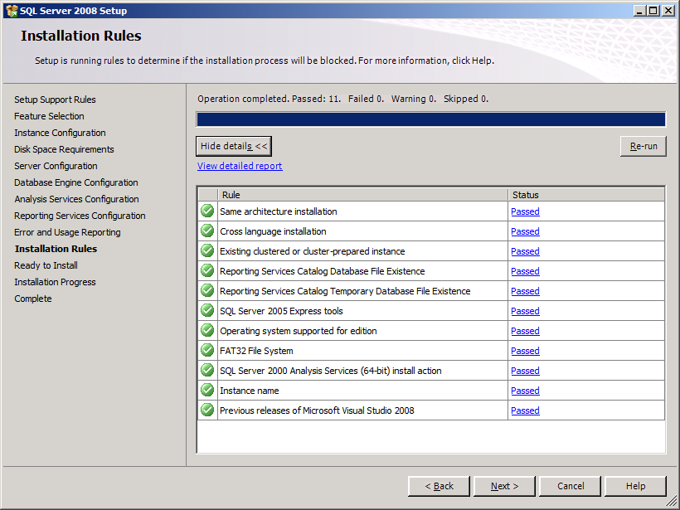
Review the summary, all rows should contain green check boxes, click ‘Next’
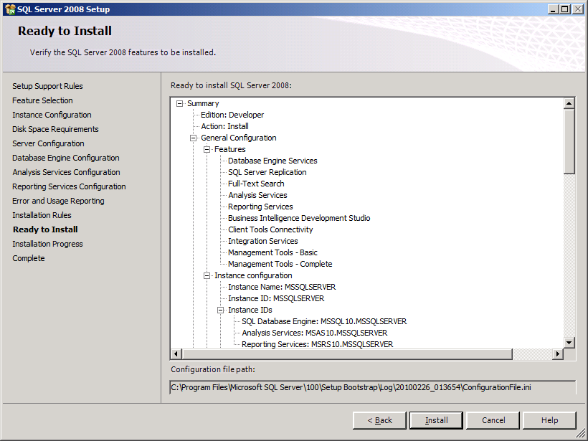
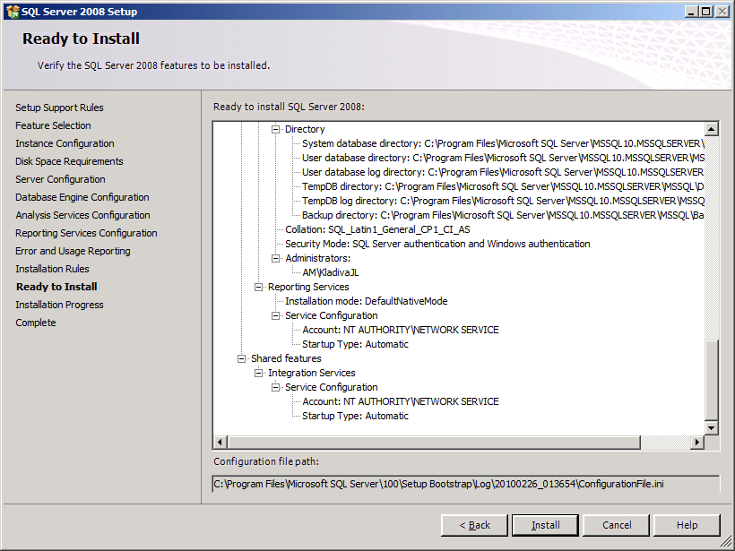
Click ‘Install’
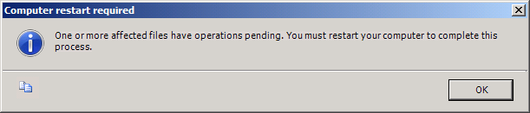
Click ‘OK’

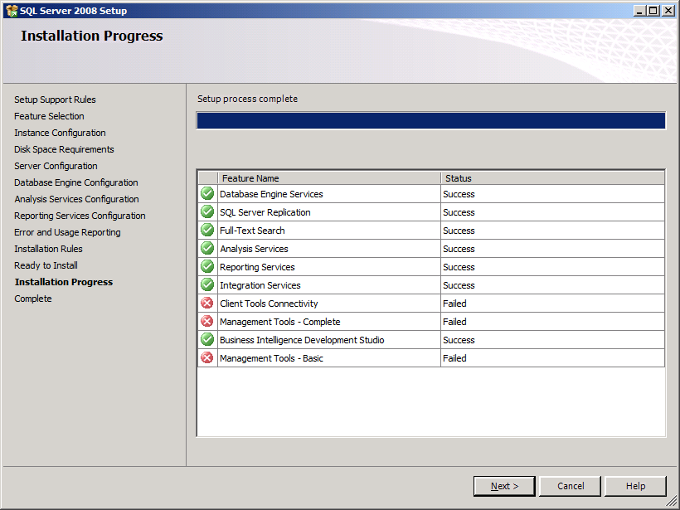
Three features failed to install properly due to being unable to read SQL Server 2008 image while running the setup from a Virtual DVD ROM program. You should see all green checkmarks, click ‘Next’ and skip ahead to Section 2.5. I had to do a ‘Repair’ to properly install these 3 features as shown below.

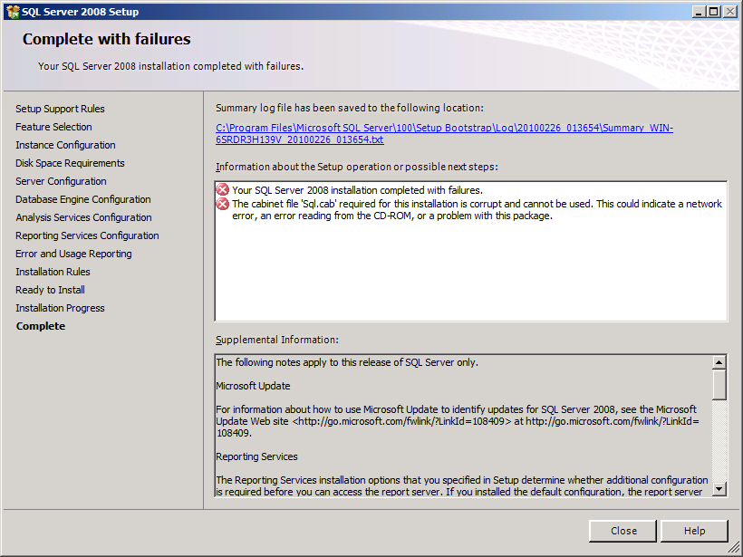
No big deal, just need to run a ‘Repair’ from the left menu on the SQL Server 2008 install menu

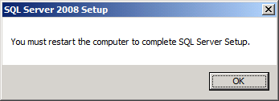
Click ‘OK’
After restart, run the SQL Server 2008 setup program again and click the ‘Repair’ link, run the ‘Repair’ option

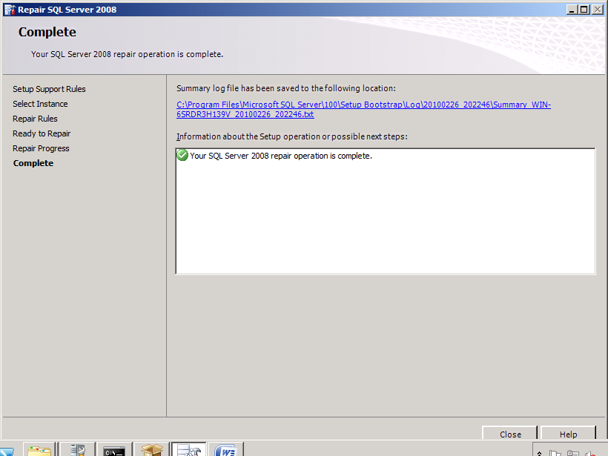
SQL Server 2008 x64 is now installed

Install SQL Server 2008 SP1 64-bit
Now install SQL Server 2008 SP1 x64, stop all the SQL Server Services to avoid a reboot, use the SQL Server Configuration Manager or Administrator Tools/Services
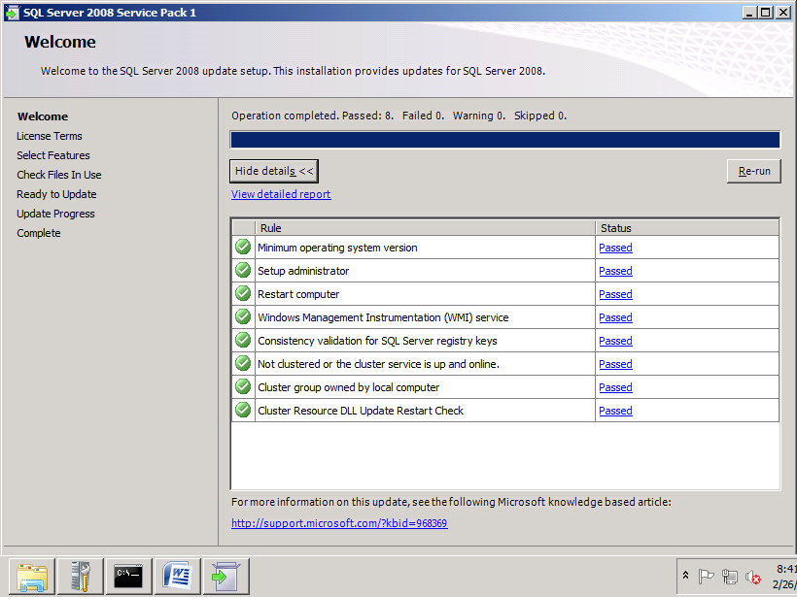
Review and click ‘Next’, you should have all green check marks
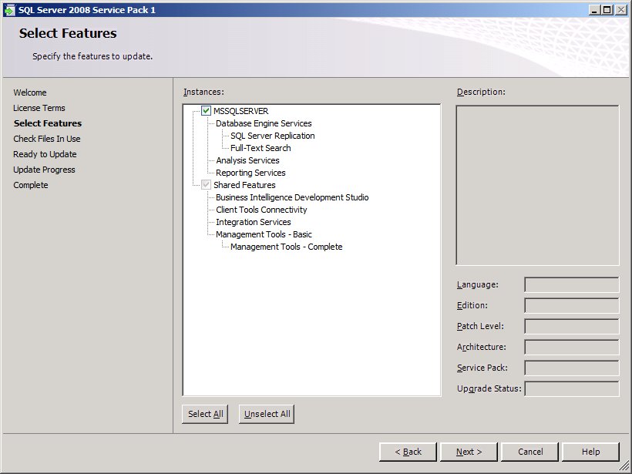
Accept the defaults and click ‘Next’
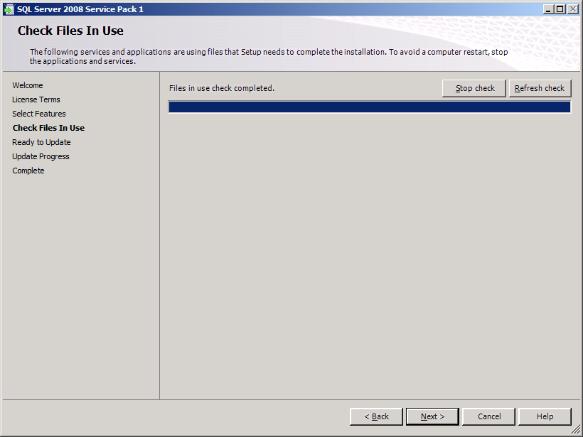
Review and click ‘Next’, to avoid a restart you can stop all the SQL Server Services prior to installing the service pack
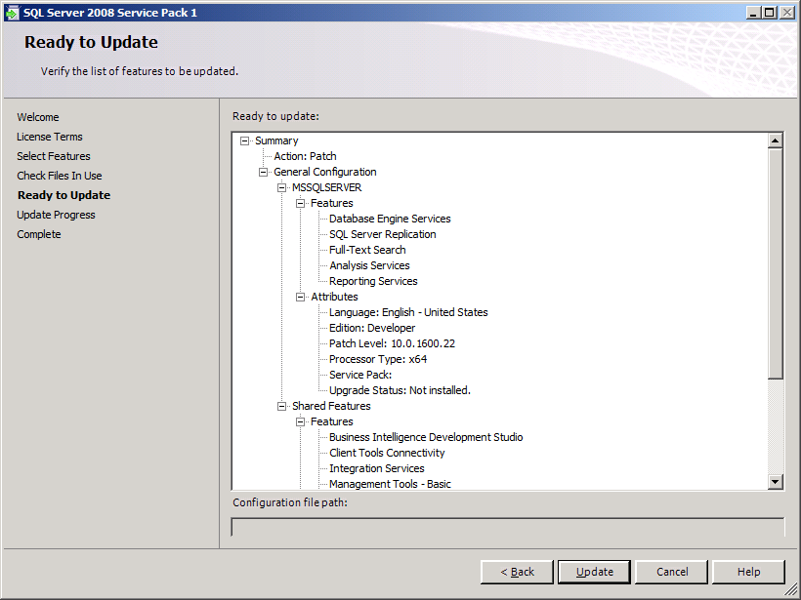
Review the summary and click ‘Update’

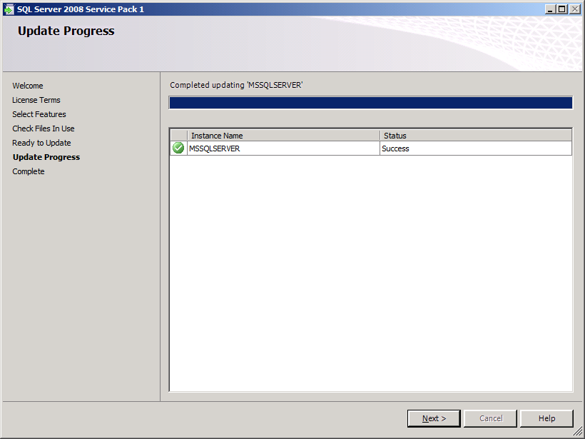
Review the results and click ‘Next’, you should see a green check mark

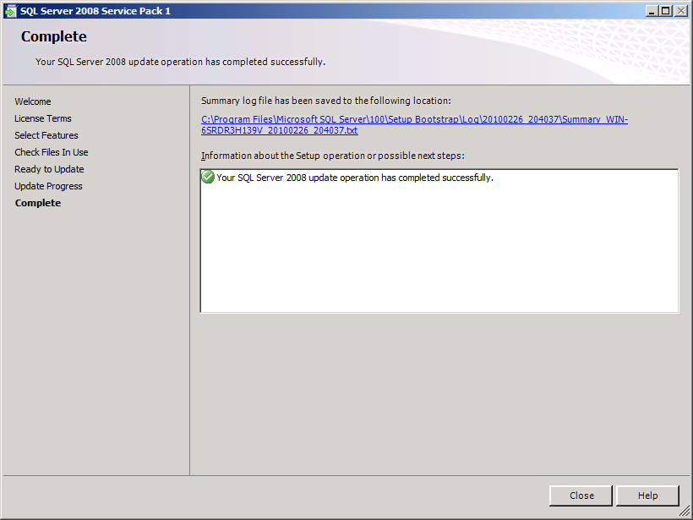
Installation is now complete, you should see a green check mark. Click ‘Close’.

Install SQL Notifications Services
This feature is required for BAM alerts. SQL Notification Services is not included in SQL Server 2008, you must download the install packages from the Microsoft Download Center listed under the ‘Feature Pack for Microsoft SQL Server 2005 – December 2008 which you can find here;
http://www.microsoft.com/downloads/details.aspx?FamilyID=536fd7d5-013f-49bc-9fc7-77dede4bb075&displaylang=en
Scroll down to the bottom of the page to the ‘Files In Download’ section and download these packages;
Microsoft SQL Server Native Client X64 Package (sqlncli_x64.msi)
Microsoft SQL Server 2005 Management Objects Collection X64 Package (SQLServer2005_XMO_x64.msi)
Microsoft SQL Server 2005 Notification Services Client Components X64 Package (SQLServer2005_NS_x64.msi)
Once you have download and saved off the 3 MSI packages, install the SQL Server Native Client
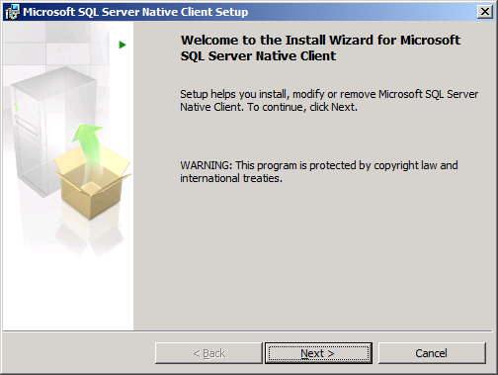
Click ‘Next’

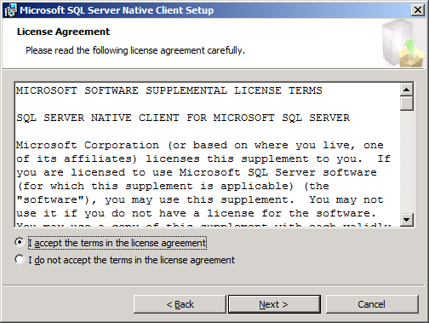
Accept the terms and click ‘Next’
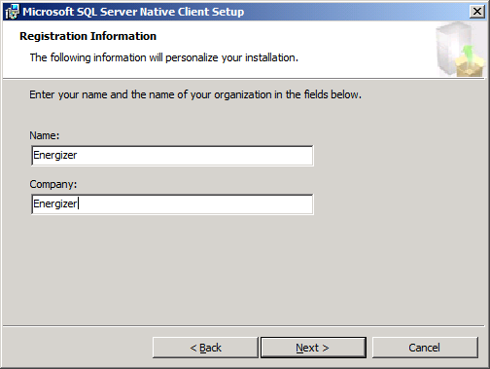
Fill out the form and click ‘Next’
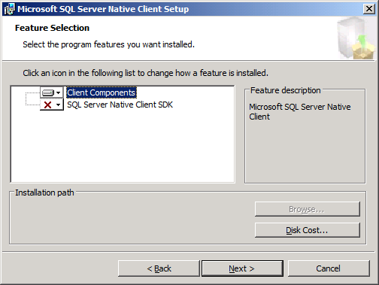
Install only the ‘Client Components’ and click ‘Next’

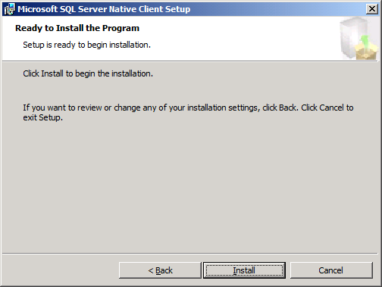
Click ‘Install’

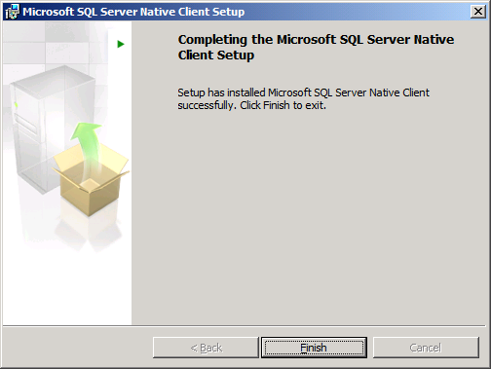
You should see a message that it installed successfully, click ‘Finish’
Next install the Microsoft SQL Server 2005 Management Objects Collection by kicking off the
SQLServer2005_XMO_x64.msi
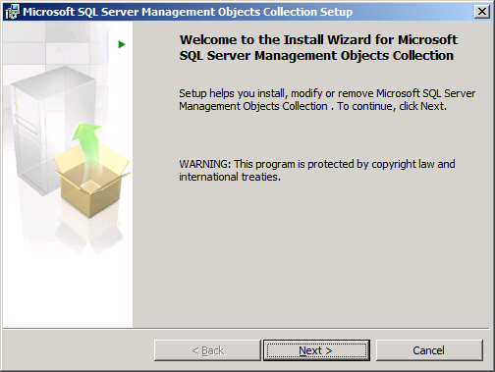
Click ‘Next’

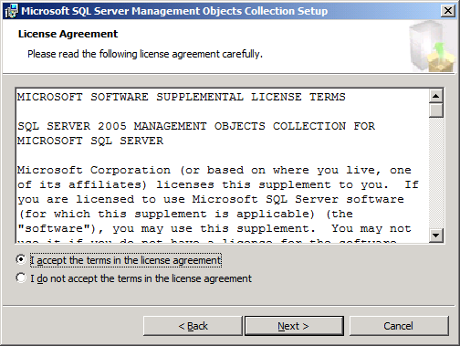
Accept the terms and click ‘Next’

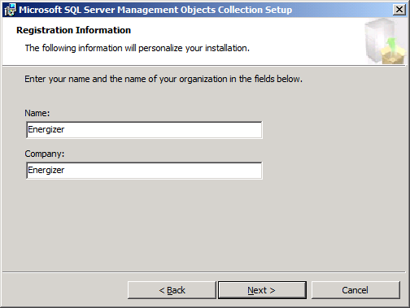
Fill out the form and click ‘Next’

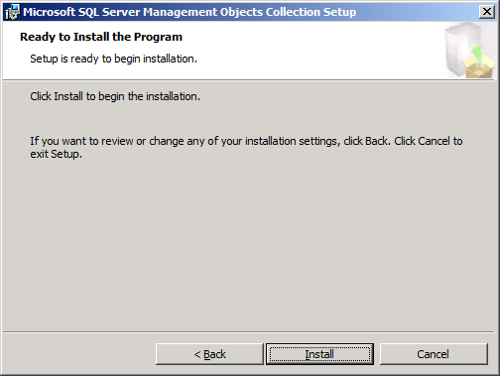
Click ‘Install’

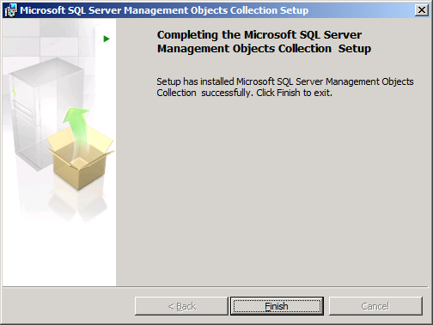
You should see a message stating the install was successful, click ‘Finish’
Next install the Microsoft SQL Server 2005 Notification Services Client Components by kicking off the SQLServer2005_NS_x64.msi package

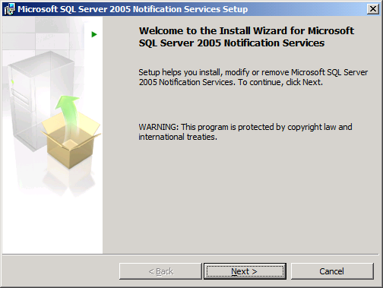
Click ‘Next’
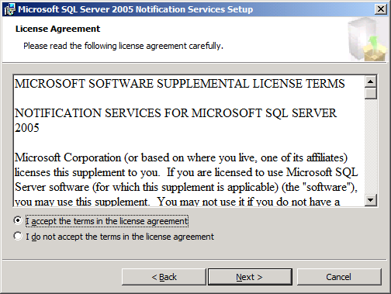
Accept the terms and click ‘Next’

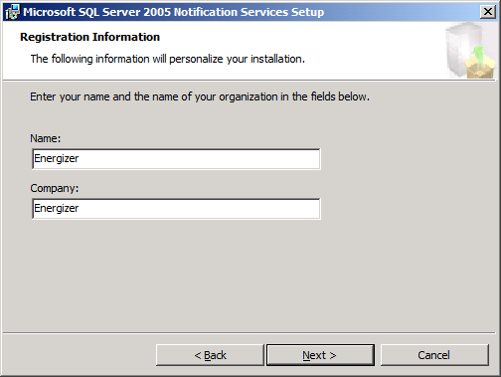
Fill out the form and click ‘Next’

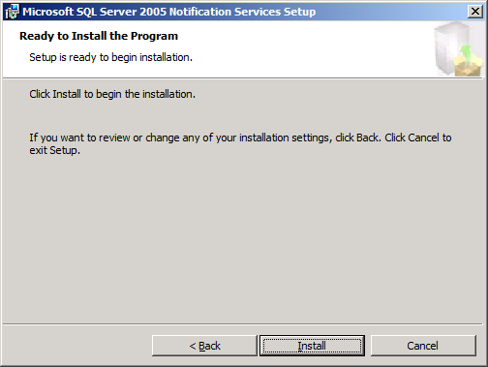
Click ‘Install’

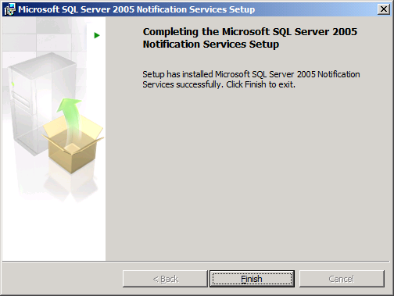
You should see a message stating the install was successful, click ‘Finish’
Installation is now complete, you should see a green check mark. Click ‘Close’.

Windows SharePoint Services 3.0 x64 with Service Pack 2
First we must configure IIS and ASP.NET 2.0 for 64-bit prior to installing Windows SharePoint Services 3.0 x64 with Service Pack 2 which runs under 64-bit
To use the adsutil.vbs script you must install the IIS 6.0 Management Tools
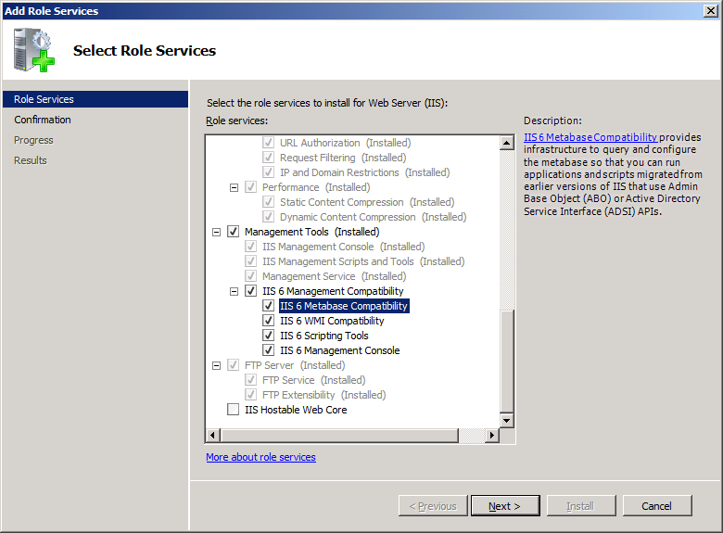
Click ‘Next’
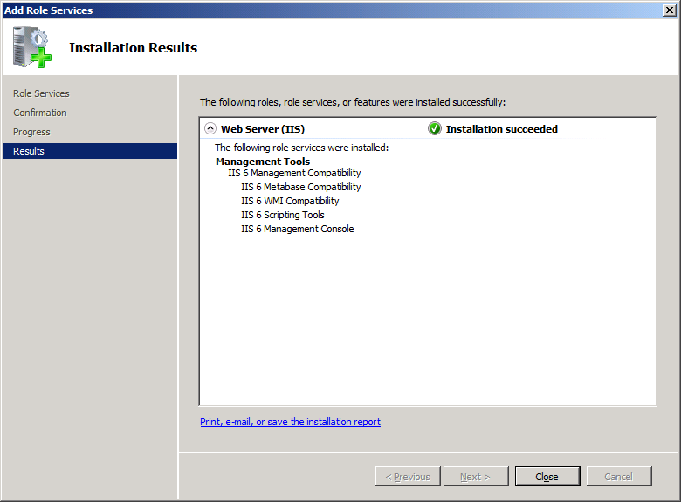
Review and click ‘Close’
Configure ASP.NET 2.0 and IIS for 64-bit mode:
- Click ‘Start’, click ‘Run’, type ‘cmd’, and then click ‘OK’
- Type the following at the command line:
cscript %Systemdrive%\inetpub\adminscripts\adsutil.vbs SET W3SVC/AppPools/Enable32bitAppOnWin64 0
- Next install ASP.NET 2.0 (64-bit) and the script maps at the IIS root, at the command line type:
%Systemroot%\Microsoft.NET\Framework64\v2.0.50727\aspnet_regiis.exe –I –enable
- Then at the command line type:
iisreset
- Close the command prompt, you results should look like this;

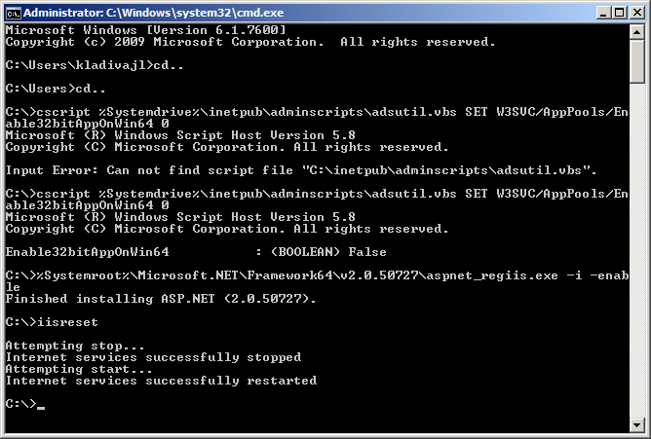
Screenshot of results
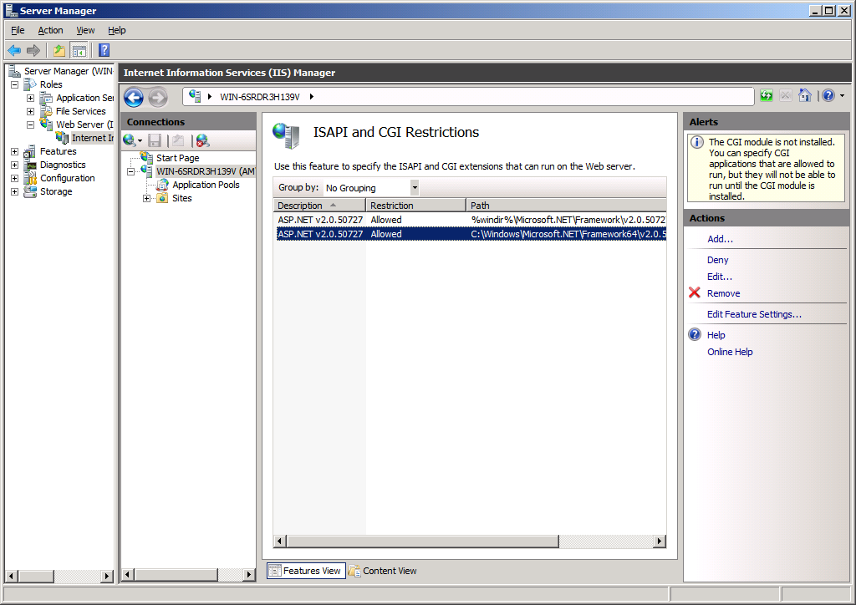
Verify that ASP.NET 2.0 64-bit is allowed in IIS
Next, install Windows SharePoint Services 3.0 x64 with Service Pack 2

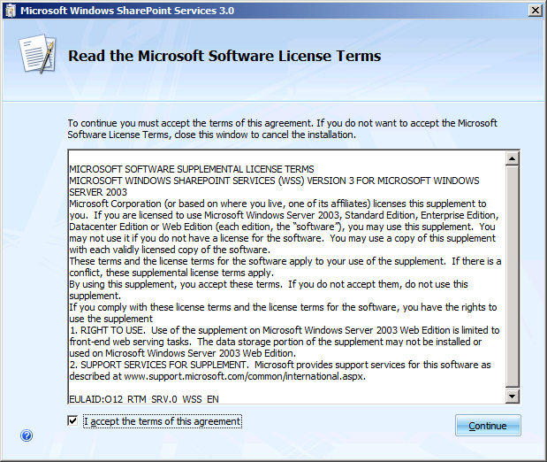
Accept the terms and click ‘Continue’
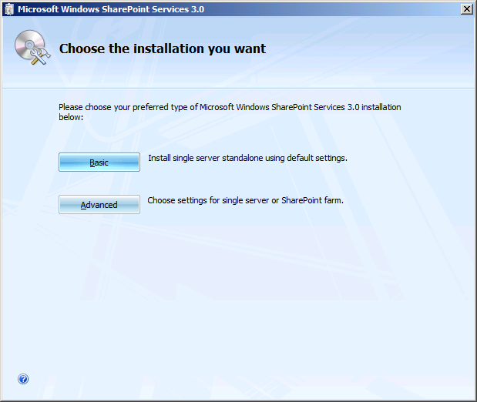
Click ‘Advanced’
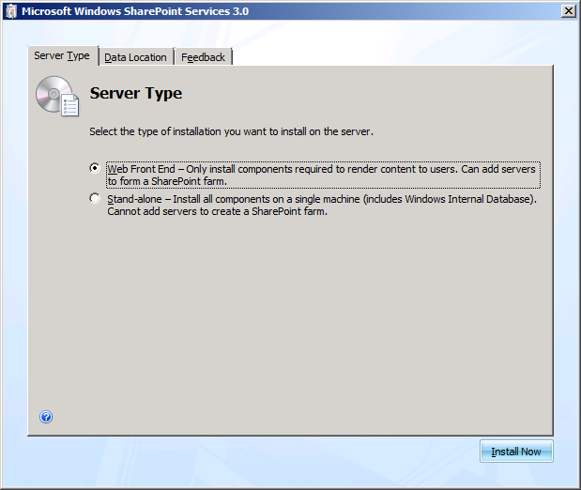
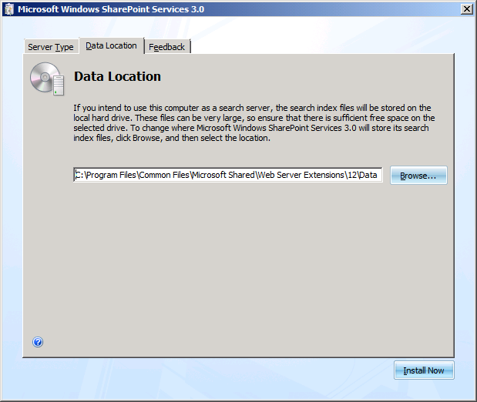
Select ‘Web Front End’, you can change the location for the install on the ‘Data Location’ tab, click ‘Install Now’

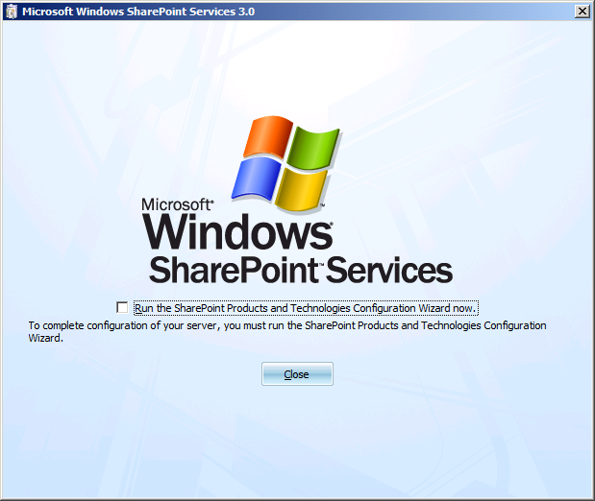
Clear the checkbox, click ‘Close’, installation is now complete

Next, run the ‘SharePoint Products and Technologies Configuration Wizard’ to configure Windows SharePoint Services

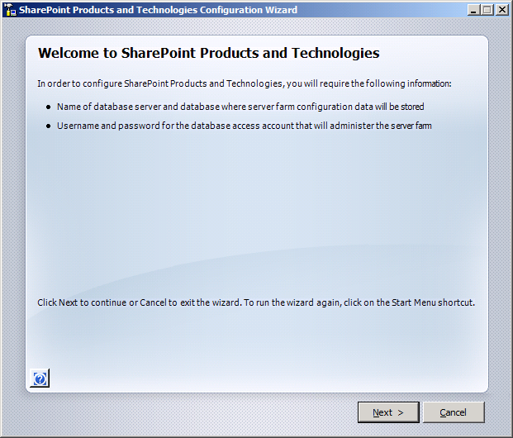
Click ‘Next’

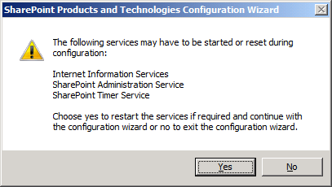
Click ‘Yes’

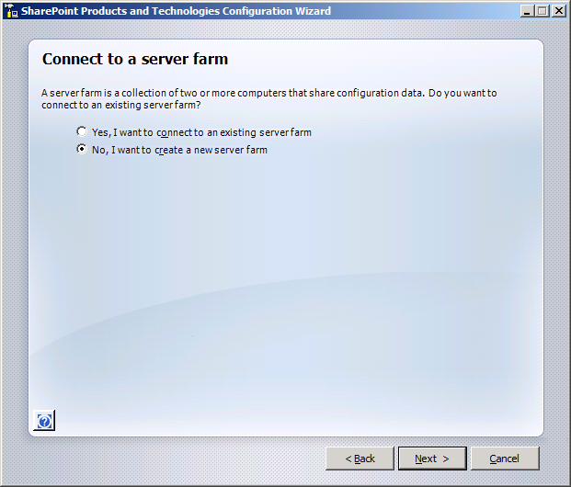
Select ‘No, I want to create a new server farm’ and click ‘Next’
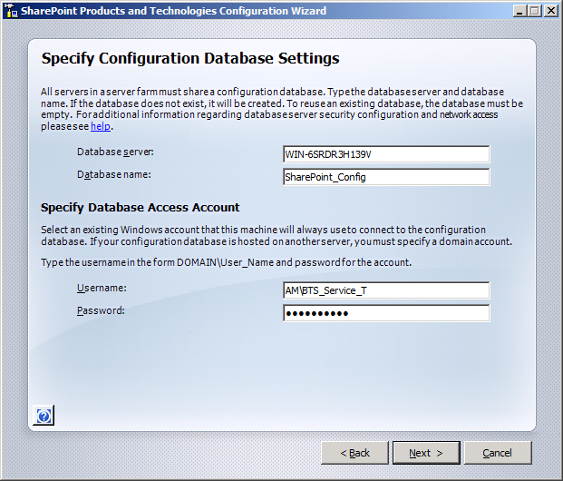
Accept the defaults for the Database server and Database name and enter a username and password for a domain account for WSS to run under, click ‘Next’

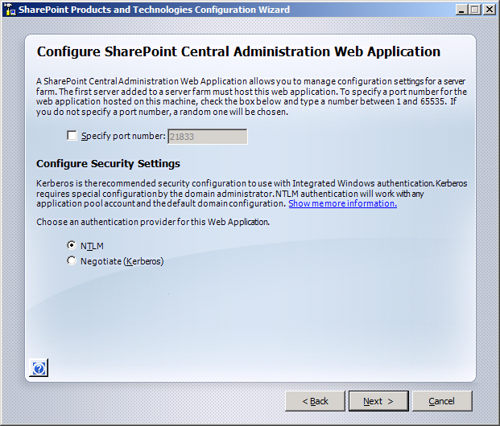
Select ‘NTLM’ and accept the default port provided and click ‘Next’

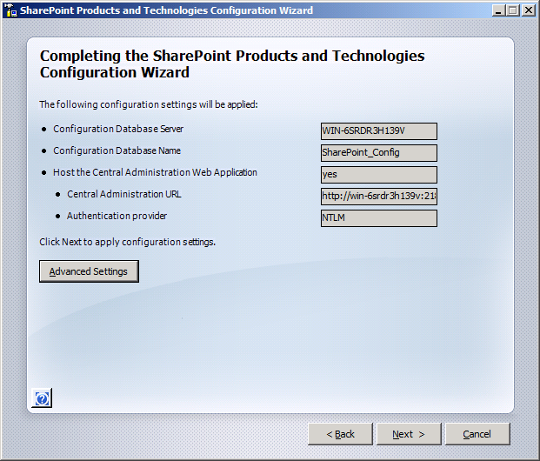
Review the settings and click ‘Next’

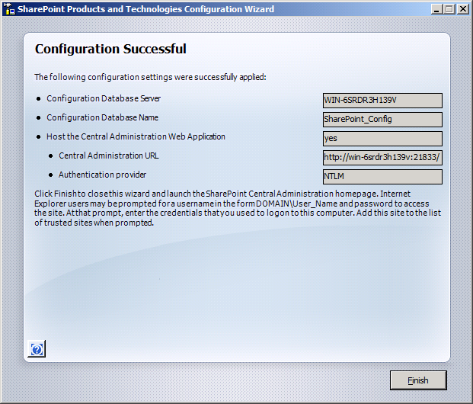
You should see a message that the configuration was successful, click ‘Finish’
Next, we need to create a web application under the ‘SharePoint Central Administration’ tool. First add the SharePoint Central Administration web site to your ‘Trusted Sites’ in Internet Explorer, otherwise the pages will not function correctly on Windows 2008.
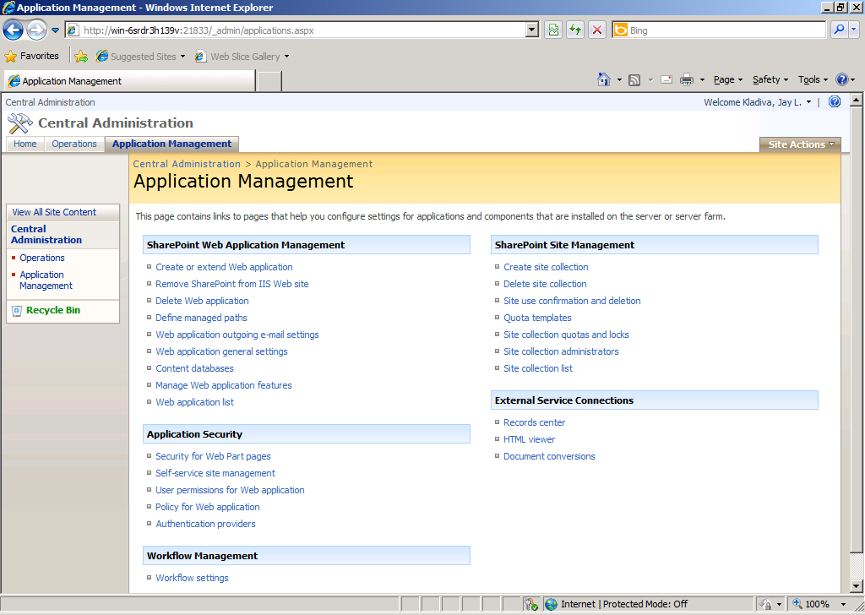
Click the ‘Application Management’ link and then click ‘Create or extend Web application’
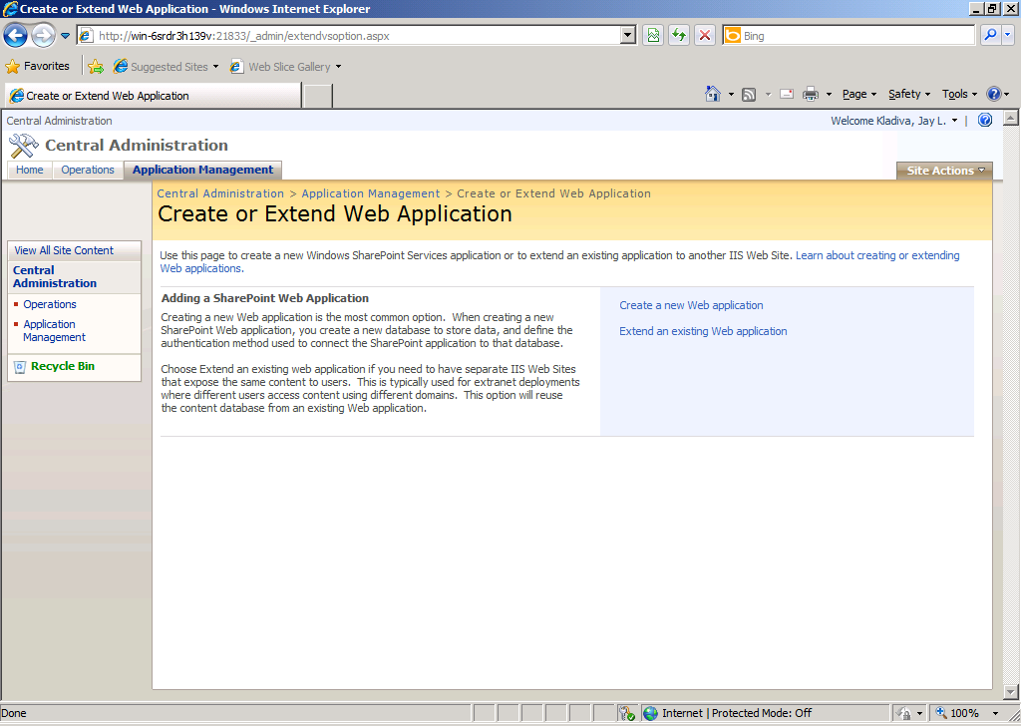
Click ‘Create a new Web application’

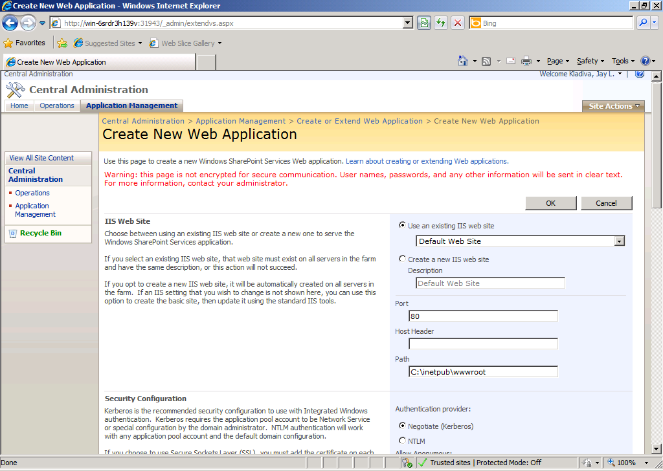
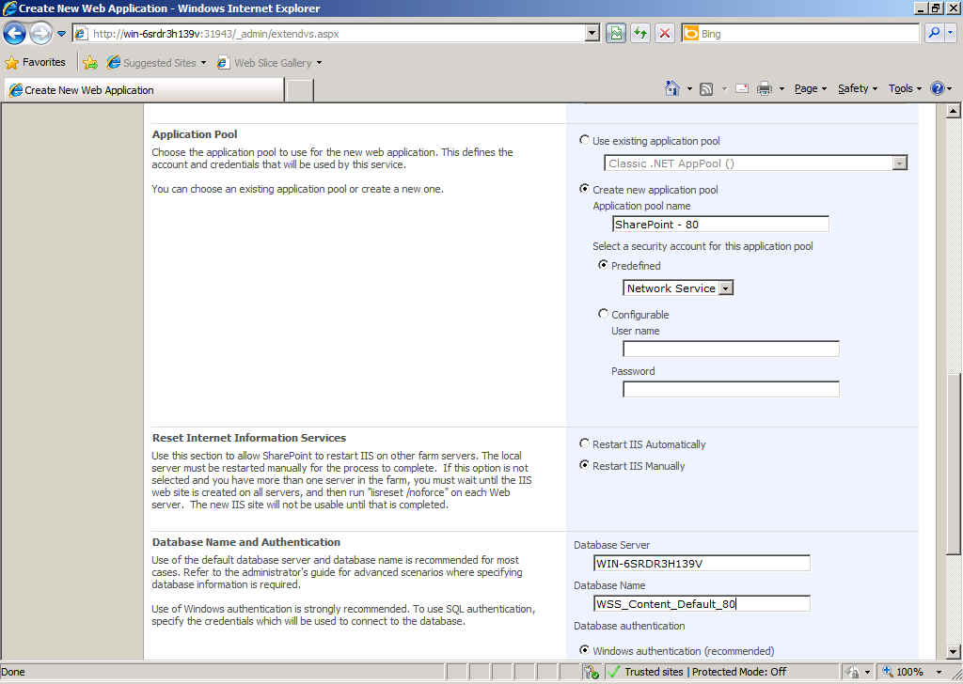
Select ‘Default Web Site’, ‘Restart IIS Manually’, ‘Network Service’, ‘Windows authentication’, rename the Database Name to something more recognizable if you want, then click ‘OK’

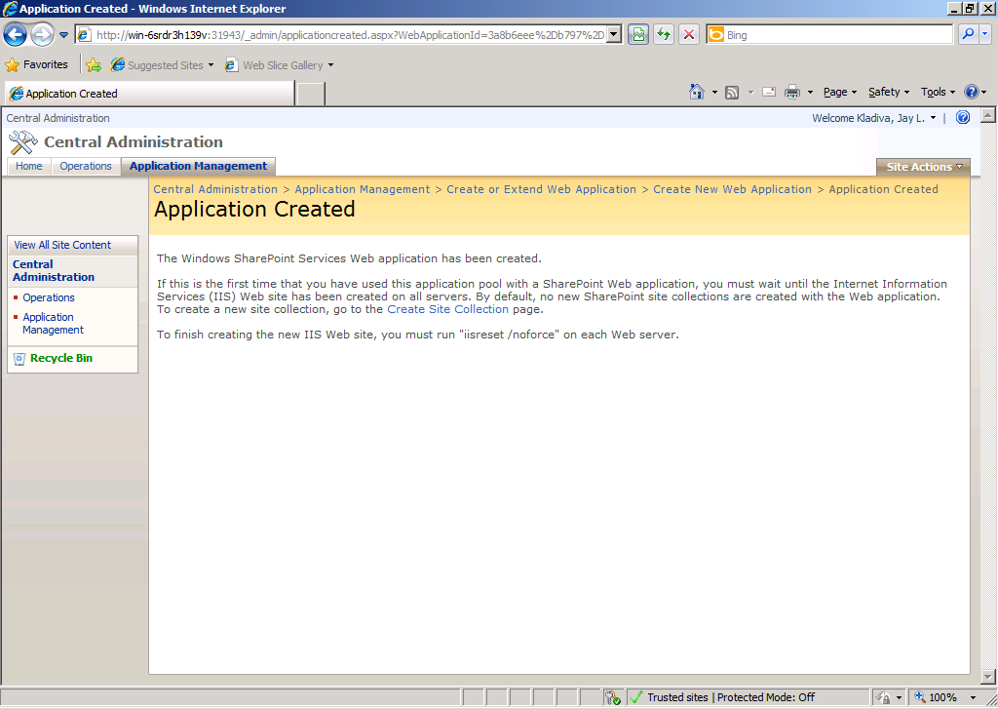
You should see a message ‘Application Created’, next click ‘Start’, click ‘Run’, type ‘cmd’, click ‘OK’, then type;
iisreset /noforce
Under the ‘Web Application List’ in SharePoint Central Administration you should see the ‘Default Web Site’ and ‘SharePoint Central Administration v3’ in the list
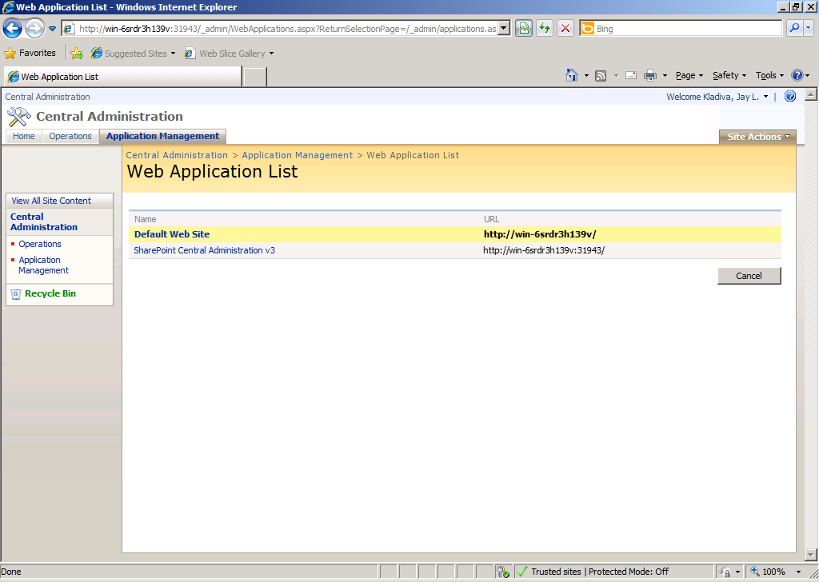
Close the SharePoint Central Administration tool, configuration is complete

Disable the Shared Memory Protocol
Click ‘Start’, ‘All Programs’, click ‘SQL Server 2008’, click ‘Configuration Tools’, then click ‘SQL Server Configuration Manager’
In the SQL Server Configuration Manager, click on the ‘SQL Server Network Configuration’ node and expand it, under ‘Protocols for MSSQLSERVER’ right-click the ‘Shared Memory’ protocol and disable it.
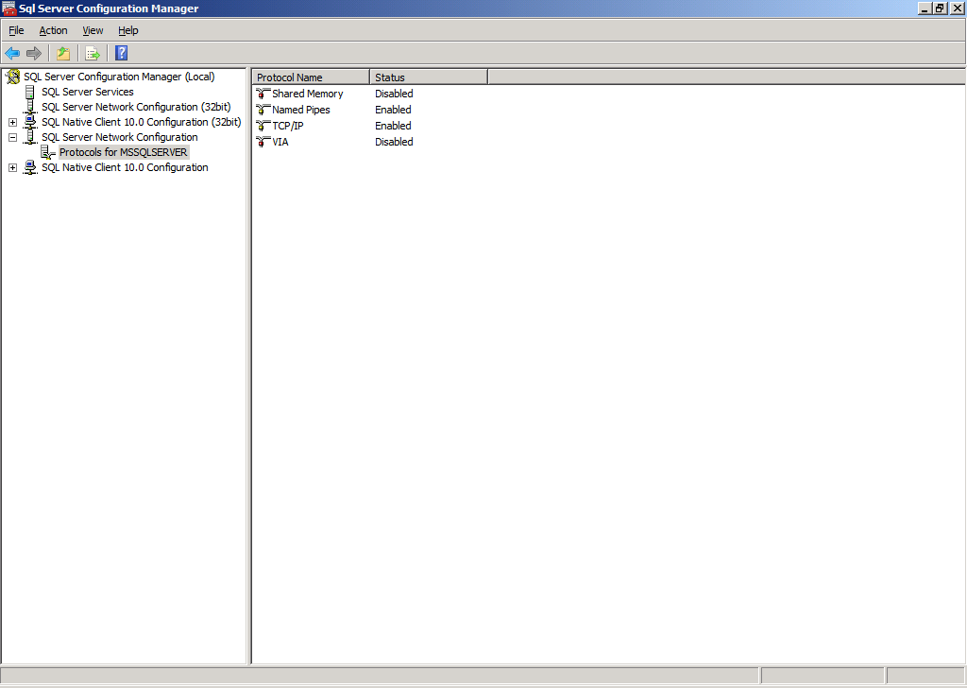
Next, click on ‘SQL Server Services’, right-click ‘SQL Server (MSSQLSERVER)’ and click ‘Stop’, then ‘Start’ to make the settings take effect.
Close the SQL Server Configuration Manager

Join the Local Administrators Group
BizTalk requires you to be a Local Administrator to install and configure BizTalk.
Click ‘Start’, ‘Control Panel’, ‘Administrator Tools’, ‘Computer Management’, ‘Local Users and Groups, ‘Groups’, …..add you user account to the ‘Administrators’ group

Configure the Application Event Log
BizTalk logs its events to the Windows Application Event Log. Depending on the features you plan to install for BizTalk and the current size of the Application Event Log your installation might fail if the log exceeds its size limit. Also in production you always want a rolling list of the latest events and do not want your Application Event Log to become massive in size
Click ‘Start’, ‘Control Panel’, ‘Administrative Tools’, Event Viewer’, expand ‘Windows Logs’, and right-click ‘Application’, then click ‘Properties’, set the ‘Maximum log size’ to a reasonable number and select ‘Overwrite events as needed’.
Click ‘OK’ and close the Event Viewer
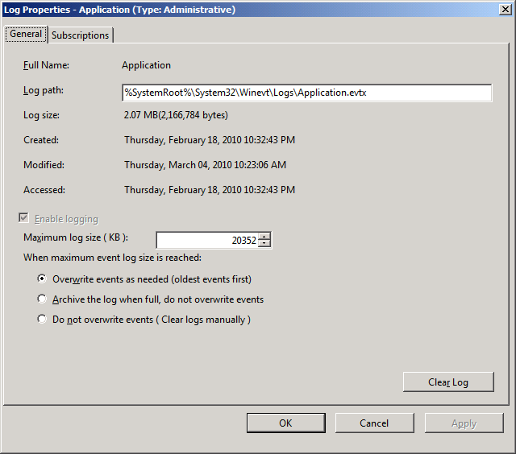

Enable TCP/IP and Named Pipes
BizTalk requires both TCP/IP and Named Pipes to be enabled to facilitate communication between your BizTalk Server and SQL Server.
Click ‘Start’, ‘All Programs’, SQL Server 2008’, ‘Configuration Tools’, then click ‘SQL Server Configuration Manager’, under ‘SQL Server Network Configuration’, click ‘Protocols for MSSQLSERVER’, verify that both TCP/IP and Named Pipes are enabled. From memory, I think that ‘TCP/IP’ is not enabled by default.
Next, click on ‘SQL Services’ in the left-hand pane, right-click ‘SQL Server (MSSQMSERVER)’, and click ‘Stop’, then ‘Start’, for the settings to take effect
Close the ‘SQL Server Configuration Manager’

Enable DTC on the Local Host Server
BizTalk requires the Microsoft Distributed Transaction Coordinator (MS DTC) to be enabled
Configure MSDTC on BizTalk and SQL Servers:
Click ‘Start’, ‘Run’, type ‘dcomcnfg’, and hit the ‘Enter’ key
Under ‘Component Services’, ‘My Computer’, right-click ‘Local DTC’ and select ‘Properties’, click the ‘Security’ tab.
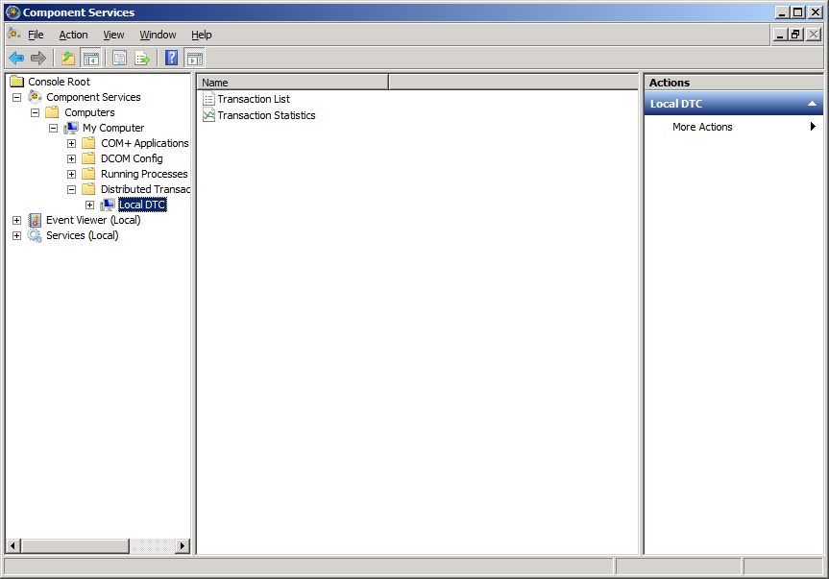
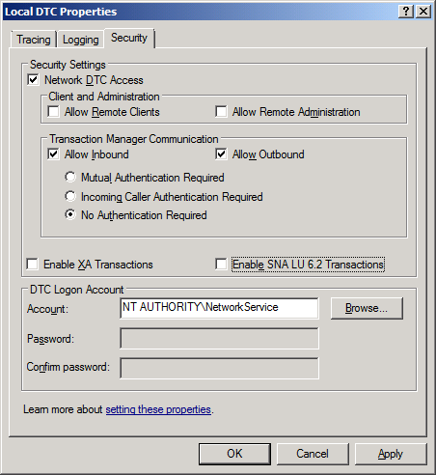
Ensure that the ‘Network DTC Access’, ‘Allow Inbound’, ‘Allow Outbound’, and ‘No Authentication Required’ options are selected and all others are cleared.
Click ‘OK’
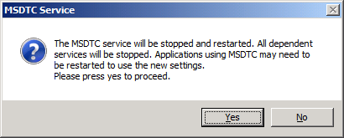
Click ‘Yes’
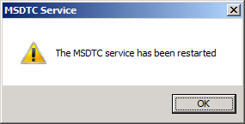
Click ‘OK’ and close the ‘Component Services’
Next, ensure that Windows Firewall has the ‘Distributed Transaction Coordinator’ listed on the ‘Exceptions’ tab
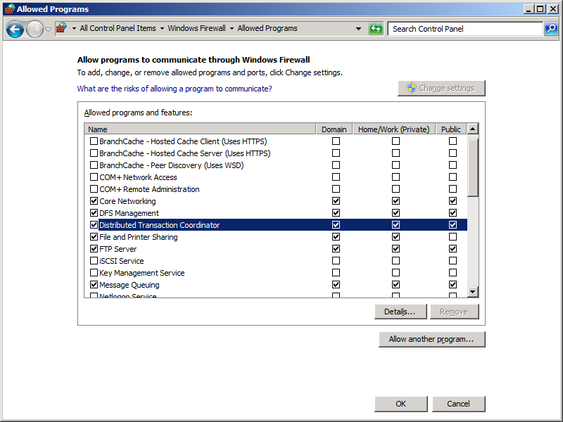
Click ‘OK’
Restart the Distributed Transaction Coordinator from ‘Administrative Tools’, ‘Services’, right-click ‘COM+ System Application’ and select ‘Restart’. Close the window, now you’re ready for the BizTalk installation.

BizTalk Server 2009 64-bit Installation
Insert the BizTalk Server 2009 DVD or double-click ‘Setup.exe’ on your mounted .iso image or file on your hard drive
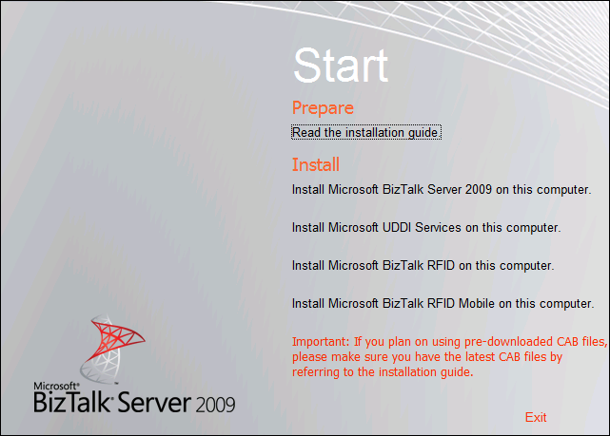
Click the ‘Install Microsoft BizTalk Server 2009 on this computer’ link

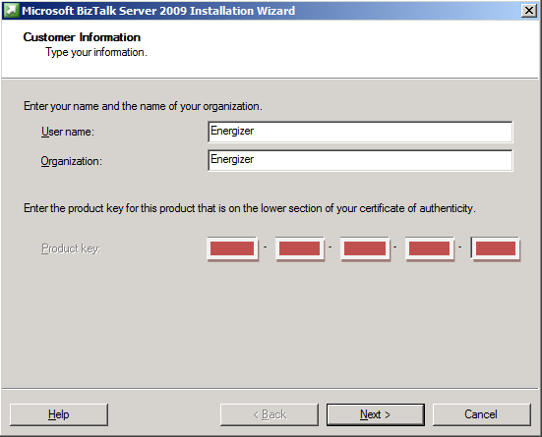
Fill out the form and click ‘Next’

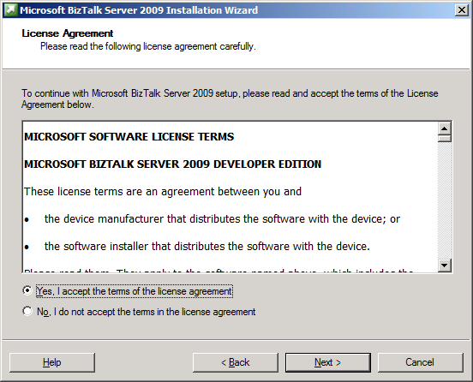
Accept the terms and click ‘Next’
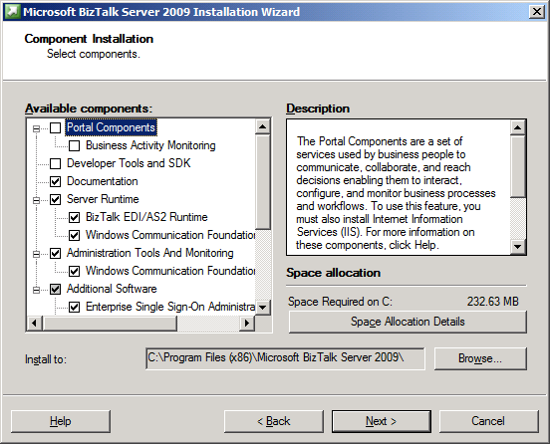
Select all the options except ‘Developer Tools and SDK’, ‘Portal Components’ and ‘BAM’. The BAM Portal can only be installed on a 32-bit server, after the installation of BizTalk you can install the BAM Tools which allows installs the BAM databases to store events, then you can create your own portal in SharePoint, ASP.NET, etc. to display BAM information to your business. Click, ‘Next’

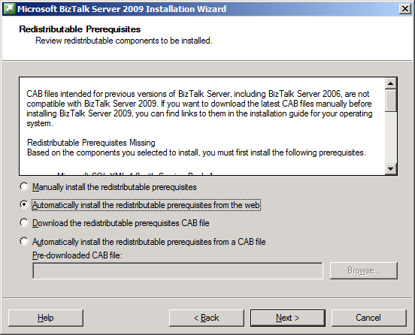
Select, ‘Automatically install the redistributable prerequisites from the web’ and click ‘Next’
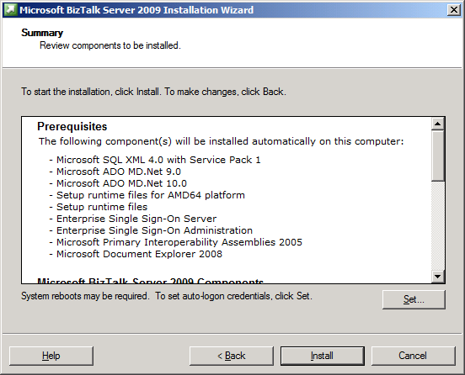
Review and click ‘Install’

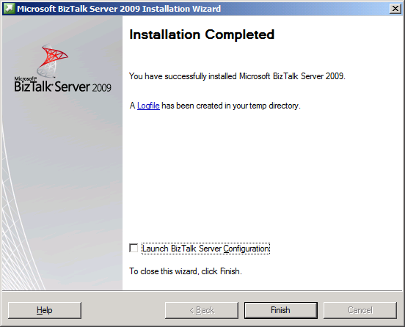
You should see a message that BizTalk was installed successfully, click on the ‘Logfile’ link to review the log if any errors were encountered. Clear the check box and click ‘Finish’, BizTalk is now installed but not configured.

Verify Your BizTalk Server 2009 Installation
Microsoft lists this step in their Installation guide.
Click ‘Start’, ‘Run’, type ‘regedit’, press ‘Enter’, then browse to the HKEY_LOCAL_MACHINE\SOFTWARE\Microsoft\BizTalk Server\3.0 key
If the key exists then your setup succeeded. Also nice to know where this key is so you can view what version of BizTalk you installed by looking at the ‘ProductEdition’ key

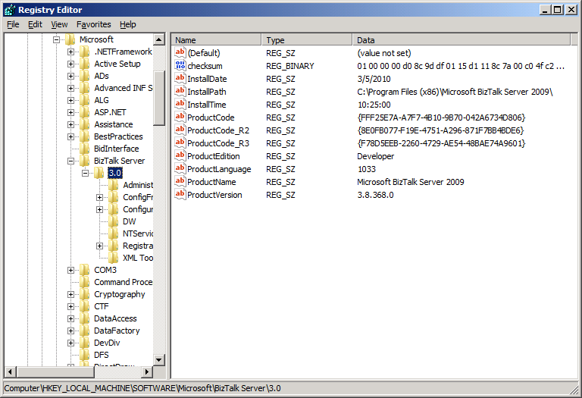
Screenshot of Registry Editor

Now you are now ready to configure BizTalk Server 2009 via the ‘BizTalk Server Configuration Wizard’.

Setup Domain Accounts For BizTalk Server 2009
You need to setup some domain accounts for the various pieces of BizTalk Server 2009. Ideally you should have separate accounts for your production environment then your development/test environments. If you share these accounts between development and production then you could make a mistake with your password in the bindings and lock up this account in production causing a host to fail.
Production BizTalk Environment
Domain User Accounts
<DOMAIN>\BTS_Service
<DOMAIN>\SSO_Service
<DOMAIN>\BTS_Host_Ins
<DOMAIN>\BTS_Iso_Host_Ins

Domain Group Accounts
<DOMAIN>\SSO_Admins
<DOMAIN>\BTS_Server_Admins
<DOMAIN>\BTS_Server_Oper
<DOMAIN>\BTS_App_Users
<DOMAIN>\BTS_Iso_Host_Users
<DOMAIN>\SPS_Enabled_Hosts

Dev/Test BizTalk Environment
Domain User Accounts
<DOMAIN>\BTS_Service_T
<DOMAIN>\SSO_Service_T
<DOMAIN>\BTS_Host_Ins_T
<DOMAIN>\BTS_Iso_Host_Ins_T

Domain Group Accounts
<DOMAIN>\SSO_Admins_T
<DOMAIN>\BTS_Server_Admins_T
<DOMAIN>\BTS_Server_Oper_T
<DOMAIN>\BTS_App_Users_T
<DOMAIN>\BTS_Iso_Host_Users_T
<DOMAIN>\SPS_Enabled_Hosts_T

TODO: Need to list permissions needed for the Domain Users and Domain Groups listed above

Configure BizTalk Server 2009
Click ‘Start’, click ‘All Programs’ click ‘Microsoft BizTalk Server 2009’, right-click BizTalk Server Configuration and then click ‘Run as Administrator’
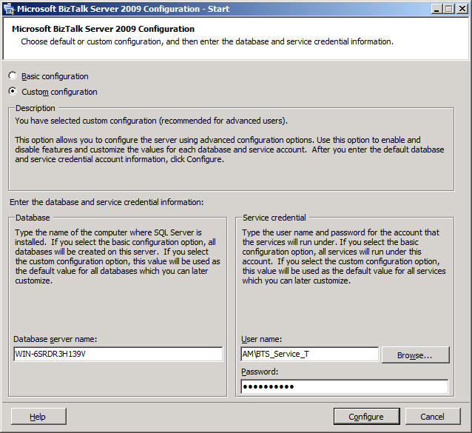
Select ‘Custom’, keep the default ‘Database server name’ for your BizTalk Server and enter a Domain Account for BizTalk to run under.
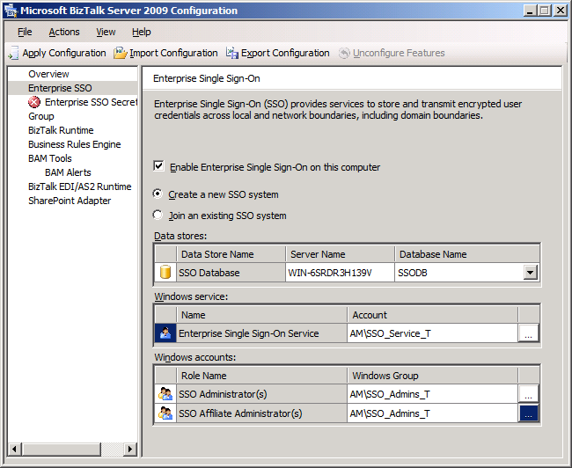
Configure Enterprise SSO, select the checkbox ‘Enable Enterprise Single Sign-On on this computer’, add the required domain account and group as shown above, leave the ‘Server Name’ and ‘Database Name’ as is
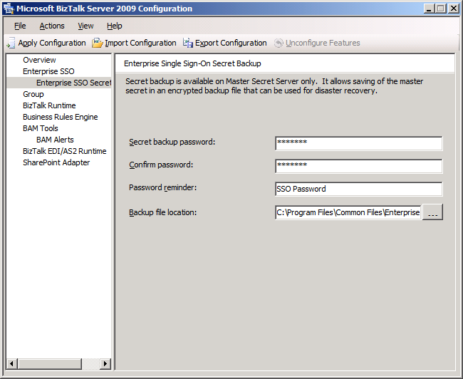
On the sub-section ‘Enterprise Single-Sign-On Secret Backup’, enter a password and a reminder, then click ‘Apply Configuration’ to configure SSO
Password: <PASSWORD>
Copy and Paste the ‘Backup file location’ path and the password you used someplace so that you know where to find them if needed
Location: C:\Program Files\Common Files\Enterprise Single Sign-On\SSO1949.bak
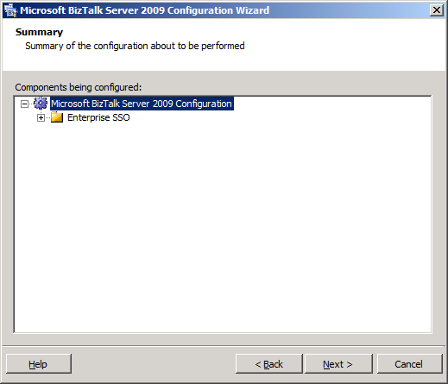
Click ‘Next’
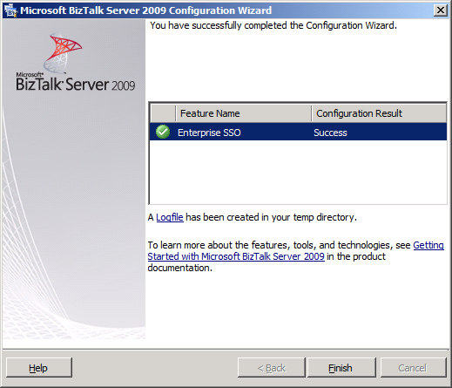
You should see a green check mark, review the log file if you encountered any errors, click ‘Finish’
Next you are ready to configure the BizTalk Group
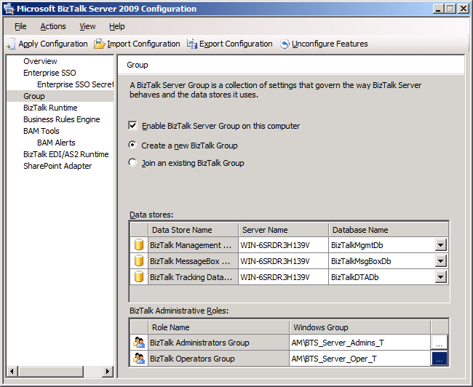
Click on ‘Group’, then check the ‘Enable BizTalk Server Group on this computer’ box, next select ‘Create a new BizTalk Group’ option. Configure the BizTalk Group using the accounts listed above, keep the default names for the database names
Review and click ‘Apply Configuration’
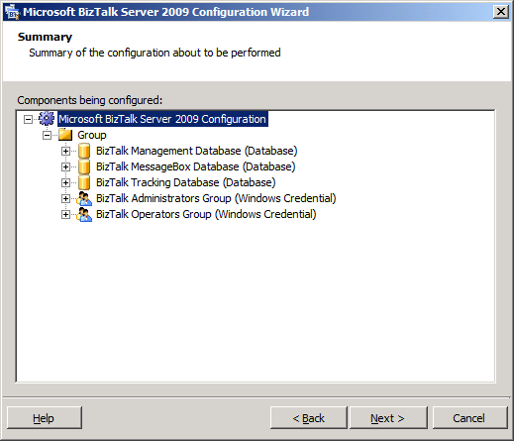
Click ‘Next’
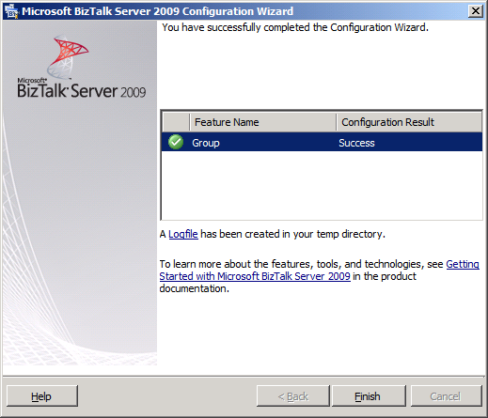
You should see a green check mark, review the log file if you encountered any errors, click ‘Finish’
Next, configure the BizTalk Runtime
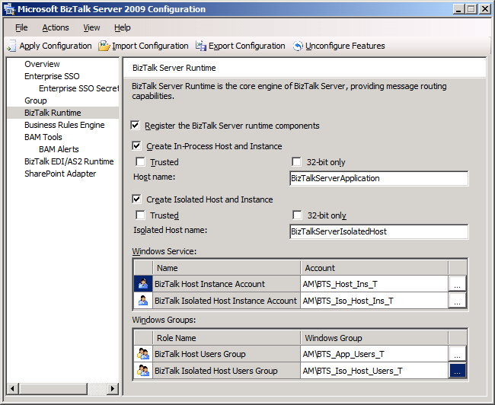
Click on the ‘BizTalk Runtime’ option and then click the ‘Register the BizTalk Server runtime components’ checkbox, configure using the options shown above. If you need to 32-bit only Host you can always add one down the road if you need one for a given protocol.
Review and then click ‘Apply Configuration’
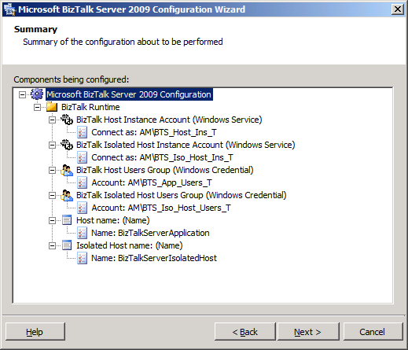
Click ‘Next’
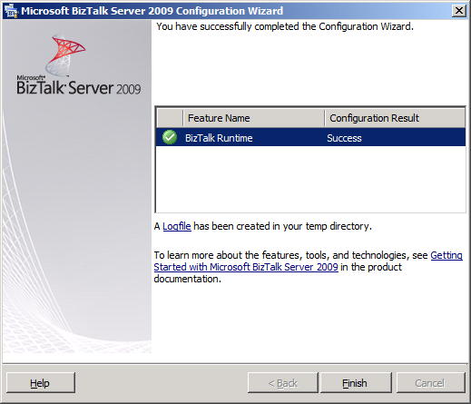
You should see a green check mark, review the log file if you encountered any errors, click ‘Finish’
Next configure the Business Rules Engine
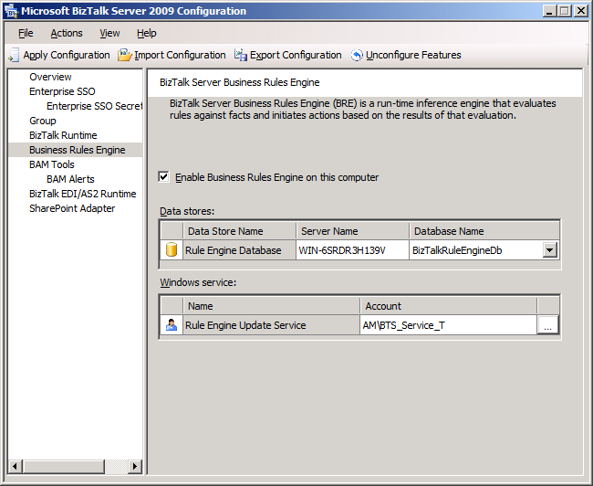
Click the ‘Business Rules Engine’ link, then check the ‘Enable Business Rules Engine on this computer’ checkbox, leave the default database name and enter a domain account for the Business Rules Engine to run under, you can create a separate domain account just for the BRE, but I just use the <DOMAIN>\BTS_Service account
Review and click ‘Apply Configuration’
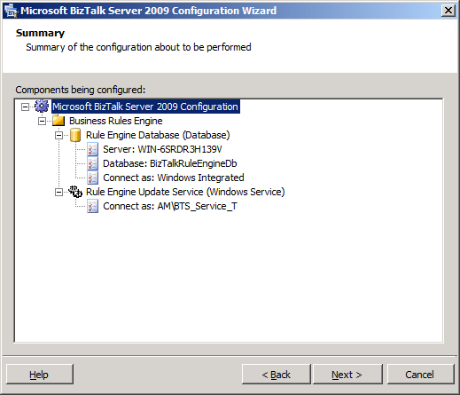
Click ‘Next’
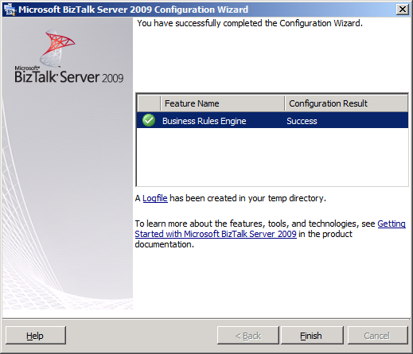
You should see a green check mark, review the log file if you encountered any errors, click ‘Finish’
Next configure the SharePoint Adapter
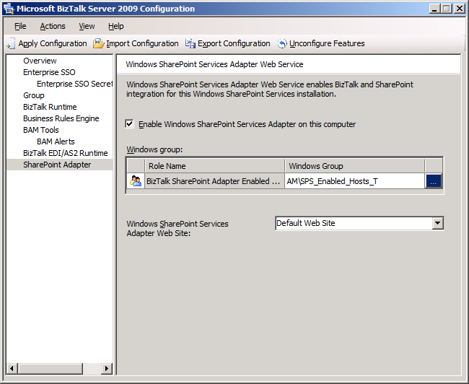
Click the ‘SharePoint Adapter’ link and then select the ‘Enable Windows SharePoint Services Adapter on this computer’ checkbox. Make sure ‘Default Web Site’ is selected and then enter the <DOMAIN>\SPS_Enabled_Hosts account for the Adapter to run under
Review and click ‘Apply Configuration’
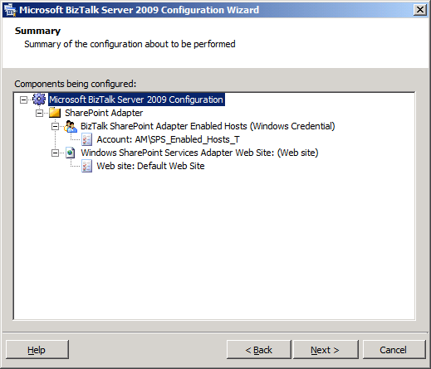
Click ‘Next’
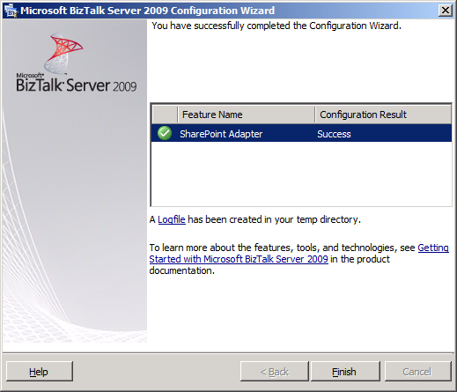
You should see a green check mark, review the log file if you encountered any errors, click ‘Finish’
Next configure the BAM Tools

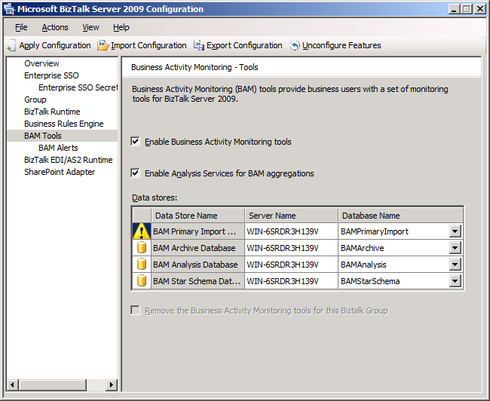
Click the ‘BAM Tools’ link and then check both checkboxes above

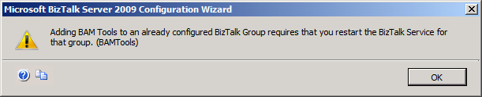
You will see a warning stating the BizTalk Service needs to be restarted, leave the default database names
Click the ‘BAM Alerts’ link and enable the BAM alerts, keep the default settings, then click ‘Apply Configuration’
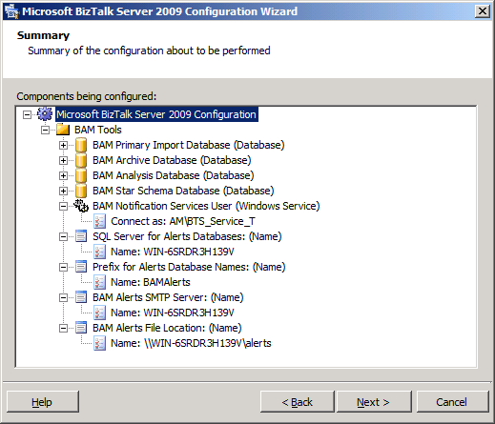
Review and then click ‘Next’
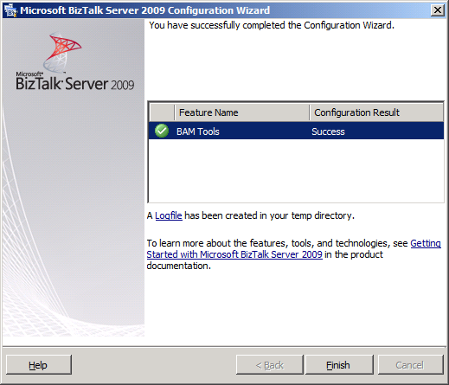
You should see a green check mark, review the log file if you encountered any errors, click ‘Finish’
Next configure the BizTalk EDI/AS2 Runtime
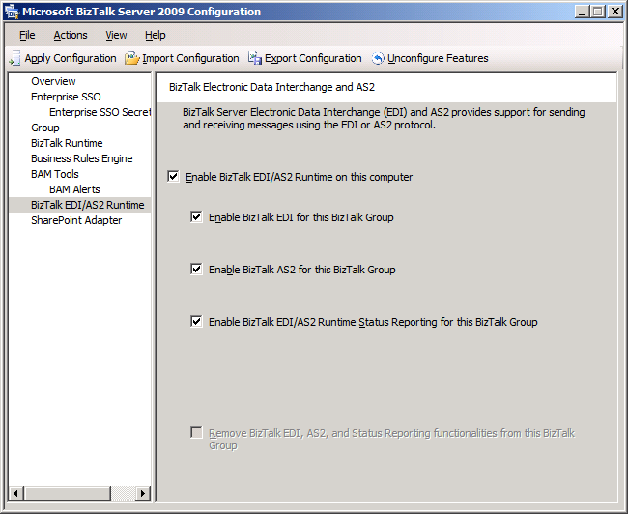
Click the ‘BizTalk EDI/AS2 Runtime’ link and then click all of the checkboxes listed above, optionally you can skip AS2 if you don’t need this functionality your organization uses another AS2 product like ‘Cyclone’.
Note: You need the BAM Tools installed prior to now if you want to enable EDI/AS2 Runtime Status Reporting
Review and click ‘Apply Configuration’
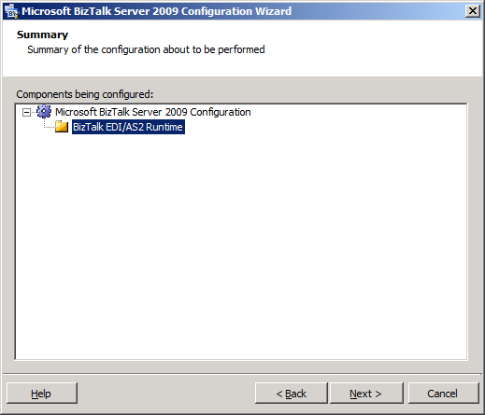
Click ‘Next’
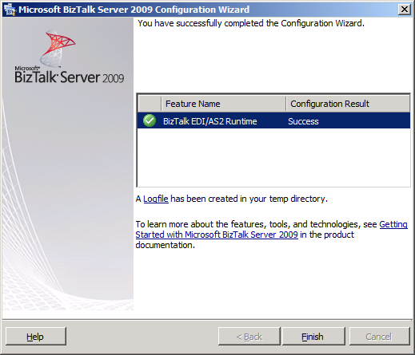
You should see a green check mark, review the log file if you encountered any errors, click ‘Finish’
BizTalk is now configured, your screen should have all green checkmarks
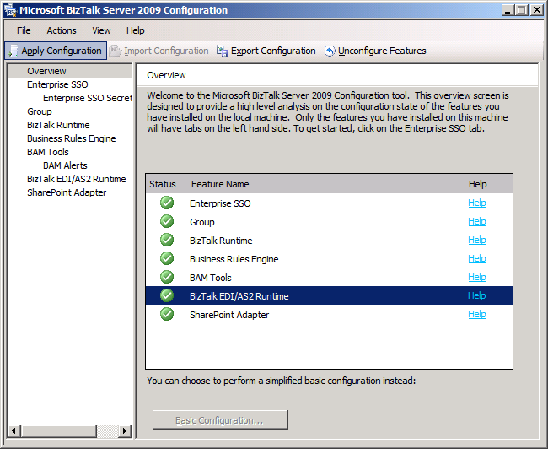
You can export your BizTalk configuration by clicking the ‘Export Configuration’ menu item
Close the BizTalk Configuration Tool, the BizTalk Server is now installed and configured

Configure BizTalk Server SQL Jobs
All of the BizTalk jobs are not configured and enab led upon installation. You must configure and enabled these.

All the BizTalk jobs will have an owner of the user that installed BizTalk. Ideally you would want to change the owner to ‘sa’ from AM\kladivajl on all BizTalk jobs.
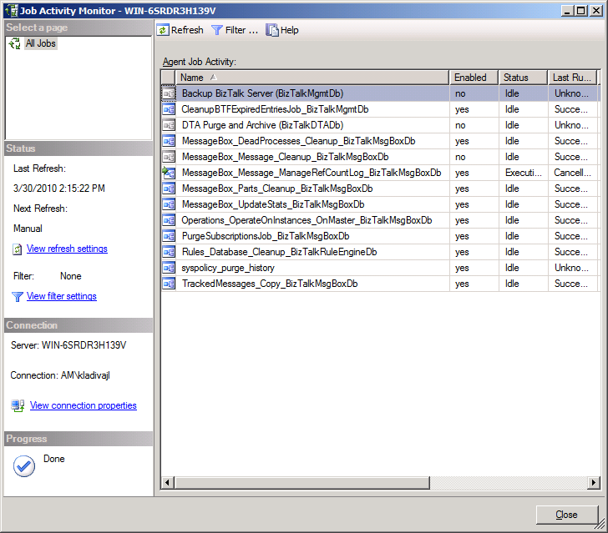
View of the BizTalk job status. As you can see 3 jobs are disabled out of the box. Two BizTalk jobs need to be configured and enabled.

DTA Purge and Archive Job
The original script after installing BizTalk looks like this:
exec dtasp_BackupAndPurgeTrackingDatabase
0, --@nLiveHours tinyint, --Any completed instance older than the live hours +live days
1, --@nLiveDays tinyint = 0, --will be deleted along with all associated data
30, --@nHardDeleteDays tinyint = 0, --all data older than this will be deleted.
null, --@nvcFolder nvarchar(1024) = null, --folder for backup files
null, --@nvcValidatingServer sysname = null,
0 --@fForceBackup int = 0 --
Review the parameters and change them:
declare @dtLastBackup datetime set @dtLastBackup = GetUTCDate()
exec dtasp_PurgeTrackingDatabase 0, 60, 90, @dtLastBackup
NOTE: You have two options, run the dtasp_PurgeTrackingDatabase or dtasp_BackupAndPurgeTrackingDatabase stored proc. We don’t archive to a remote SQL Server so we implemented dtasp_PurgeTrackingDatabase. If you want keep your tracking data for a period of a year, it would be best to archive this off to a remote SQL Server using the dtasp_BackupAndPurgeTrackingDatabase stored proc.
Enable the job and check the job to make sure it ran successfully after the defined interval

Backup BizTalk Server
This is a critical job that must be setup and configured. It consists of 3 parts out-of-the-box. Step 3 has been added to remove backups older than 3 days old so the backup drive does not fill up.
Step 1: BackupFull
Original script:
exec [dbo].[sp_BackupAllFull_Schedule] 'd' /* Frequency */, 'BTS' /* Name */, '<destination path>' /* location of backup files */
Change the location of the backup files to match your environment:
exec [dbo].[sp_BackupAllFull_Schedule] 'd' /* Frequency */, 'BTS' /* Name */, 'C:\Program Files\Microsoft SQL Server\MSSQL10.MSSQLSERVER\MSSQL\Backup' /* location of backup files */
Step 2: MarkAndBackupLog
Original script:
exec [dbo].[sp_MarkAll] 'BTS' /* Log mark name */, '<destination path>' /* location of backup files */
Change the location of the backup files to match your environment:
exec [dbo].[sp_MarkAll] 'BTS' /* Log mark name */, 'C:\Program Files\Microsoft SQL Server\MSSQL10.MSSQLSERVER\MSSQL\Backup' /* location of backup files */

Step 3: Purge Backup History
NOTE: This is a custom step that has been added to remove backups older than 3 days old so the hard drive does not fill up.
Script:
pathstring = "C:\Program Files\Microsoft SQL Server\MSSQL10.MSSQLSERVER\MSSQL\Backup\"
daysBack = 2
Set fso = CreateObject("Scripting.FileSystemObject")
For Each file In fso.GetFolder(pathstring).files
If DateValue(file.datelastModified) < DateValue(Now - daysBack) Then
fso.DeleteFile file.Path
End If
Next
Set fso = nothing
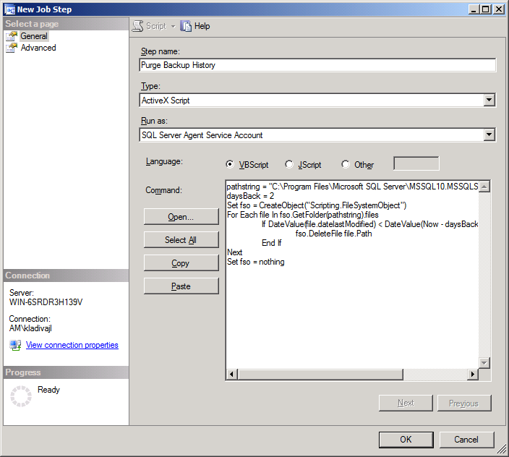
NOTE: You must grant the account NETWORK_SERVICE ‘Full Control’ to the ‘C:\Program Files\Microsoft SQL Server\MSSQL10.MSSQLSERVER\MSSQL\Backup\’ directory so it can delete files if needed, this is the account SQL Server Agent is running as.
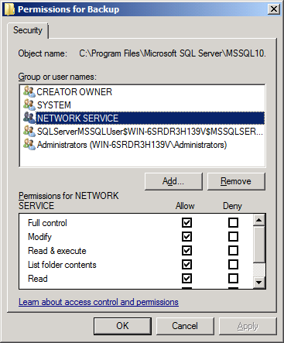
Step 4: Clear Backup History
Original script:
exec [dbo].[sp_DeleteBackupHistory] @DaysToKeep=14
Leave the default settings, enable the job, and run the job and make sure it is successful

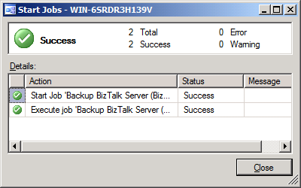
The Backup BizTalk Server job can be manually kicked off, you should see no errors.
Next review the ’Job Activity Monitor’
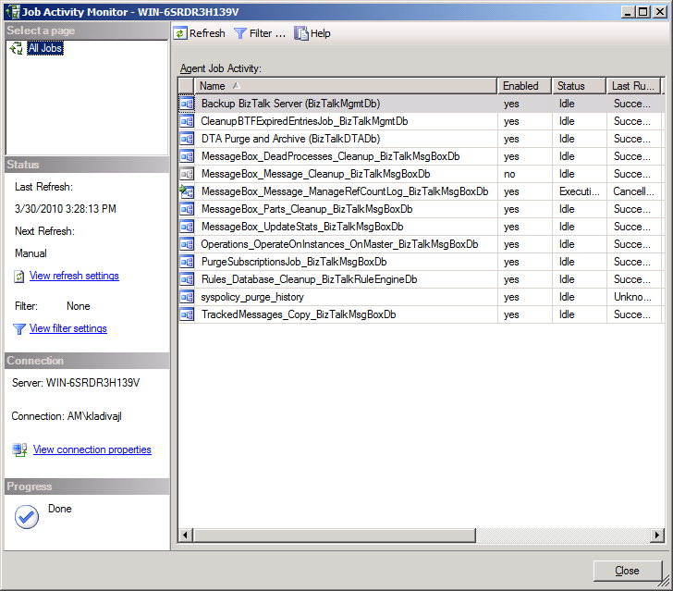
You should see only 1 job not enabled, do not enable this job, it is called by another BizTalk job. The BizTalk jobs are now configured.
NOTE: If you have custom BizTalk databases then you need to perform the steps in the next section to enable BizTalk to mark this databases for point in time recovery using the same process as the BizTalk Server databases

Backing Up Custom BizTalk Databases

To back up custom BizTalk databases you need a add entries into two BizTalk tables, see link below;
http://msdn.microsoft.com/en-us/library/aa561198(BTS.10,printer).aspx

