USING THE MICROSOFT .NET DATA PROVIDER FOR mySAP BUSINESS SUITE with SQL Server Reporting Services
Prepared by: Jay Kladiva version 1.0

COMMUNICATION MECHANISMS: RFC, BAPI, Query Tables(SQL like syntax)

CURRENT PROJECTS: None

USES: Allows RFC, BAPI, and Query Tables calls from SQL Server Reporting Services Reports to SAP

ENVIRONMENTS: Currently the Microsoft .NET Data Provider for mySAP Business Suite is installed on the USHQS098 SQL Server 2005 Development Server. Simple queries have been tested and a successful report was created using data pulled from SAP.

NOTES: The Microsoft .NET Data Provider for mySAP Business Suite must be obtained from Microsoft and is included in the SQL Server 2005 Feature Pack. Currently the Microsoft .NET Data Provider for mySAP Business Suite is only a Preview Version and is not supported for production applications.

IF YOU HAVE QUESTIONS: Contact Jay Kladiva
STEPS TO CALL BAPI, RFC, or QUERY TABLE:

Once the Microsoft .NET Data Provider for mySAP Business Suite, Preview Version is installed on the SQL Server 2005 machine, you have two methods of creating a report; using the Report Wizard or manually. Extra steps need to be taken to configure SQL Server Reporting Services to utilize the Data Provider and also to make it work in the SQL Server Reporting Services Report Designer.

Method #1 (Manually):

Create the following:
Create a new report
Create a new data source and configure the SAP data source
Create the layout for the report
Compile and run the report

Method #2 (SRS Report Wizard):

Run the wizard:
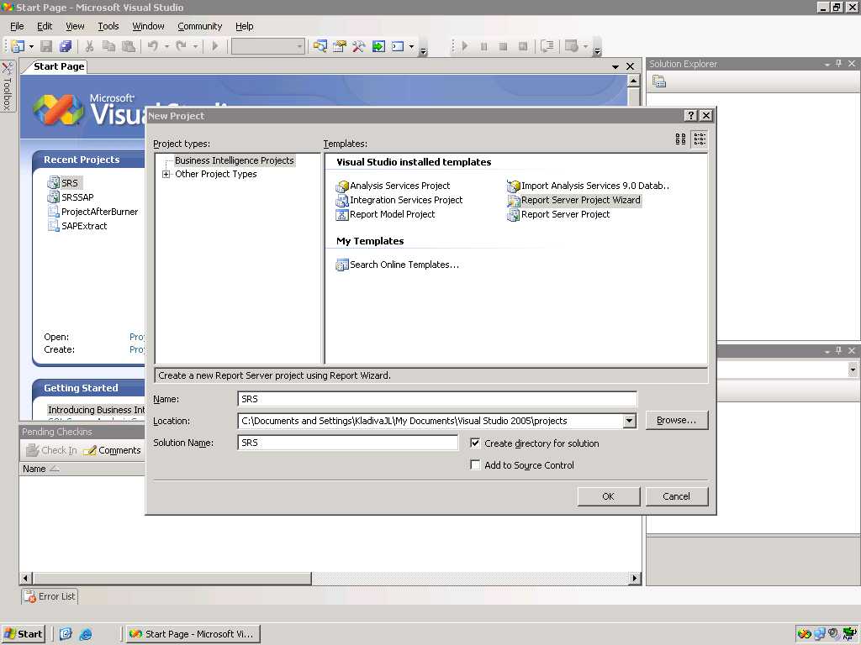

Next:
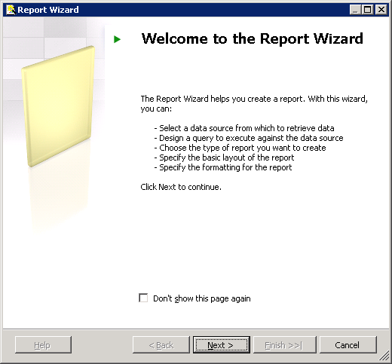

Configure the SAP connection:
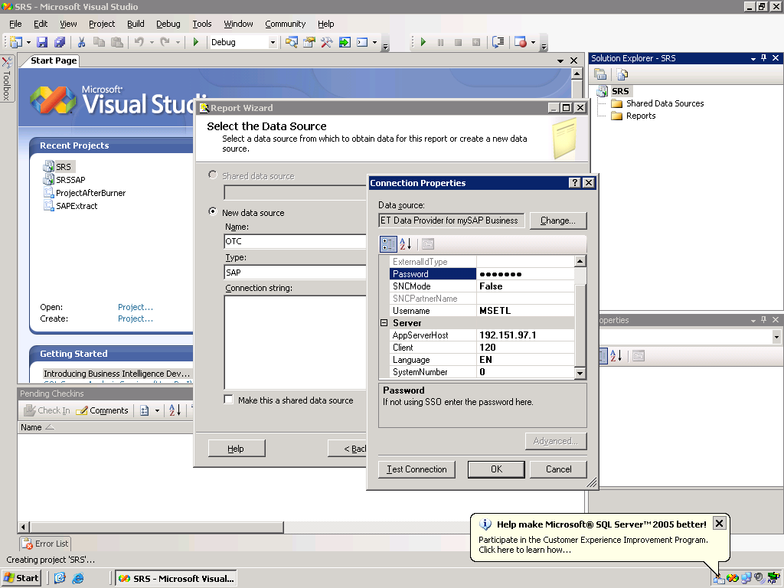

Test the connection:
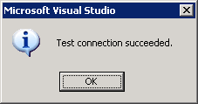

Next, Select the Data Source:

Set the Type to “SAP”

Enter the Connection String

Enter the query:
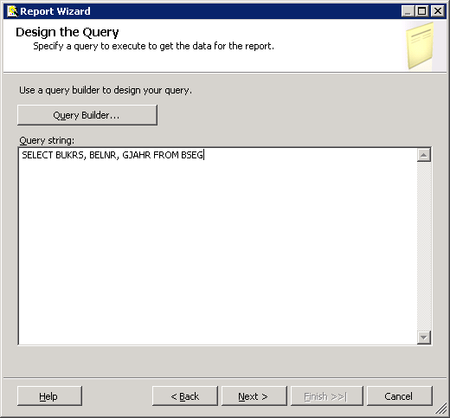
Define the report format:
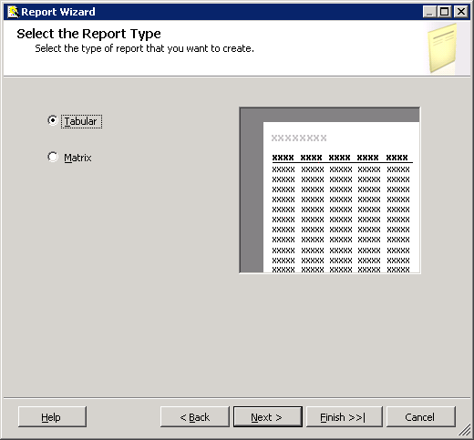

Define the field layout:
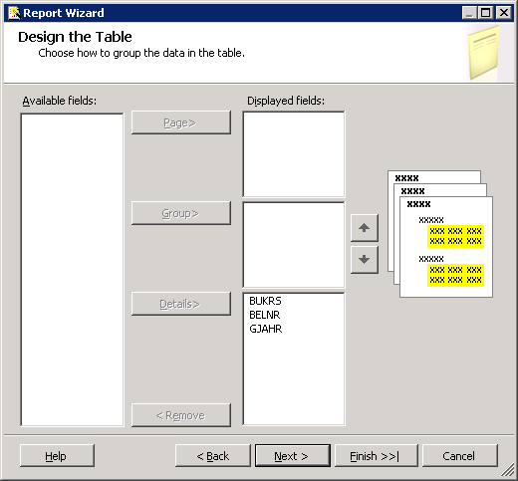

Set the style:
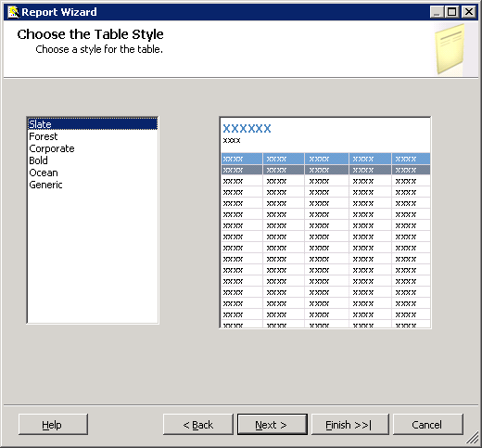

Preview or deploy the report:
