USING THE MICROSOFT .NET DATA PROVIDER FOR mySAP BUSINESS SUITE with SSIS
Prepared by: Jay Kladiva version 1.0

COMMUNICATION MECHANISMS: RFC, BAPI, Query Tables(SQL like syntax)

CURRENT PROJECTS: None

USES: Allows RFC, BAPI, and Query Tables calls from SQL Server Integration Services and SQL Server Reporting Services to SAP

ENVIRONMENTS: Currently the Microsoft .NET Data Provider for mySAP Business Suite is installed on the USHQS098 SQL Server 2005 Development Server. Simple queries have tested and they were successful in pulling SAP data.

NOTES: The Microsoft .NET Data Provider for mySAP Business Suite must be obtained from Microsoft and is included in the SQL Server 2005 Feature Pack. Currently the Microsoft .NET Data Provider for mySAP Business Suite is only a Preview Version and is not supported for production applications.

IF YOU HAVE QUESTIONS: Contact Jay Kladiva

STEPS TO CALL BAPI, RFC, or QUERY TABLE:

Once the Microsoft .NET Data Provider for mySAP Business Suite, Preview Version is installed on the SQL Server 2005 machine, you have two methods of creating an ETL package; using the SSIS Import & Export Wizard or manually.

Method #1 (Manually):

Create the following:
Control Flow – define your Data Flow task
Data Flow – define your data transformation
SAP Connection – configure SAP connection information
OLEDB Connection – configure connection to SQL Repository

Method #2 (SSIS Import & Export Wizard):

Run the wizard:
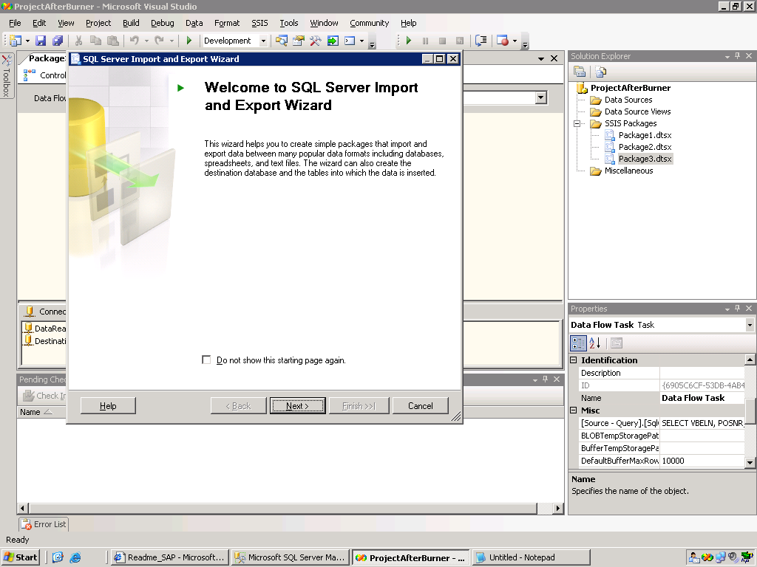

Choose the SAP DataSource and configure connection information:
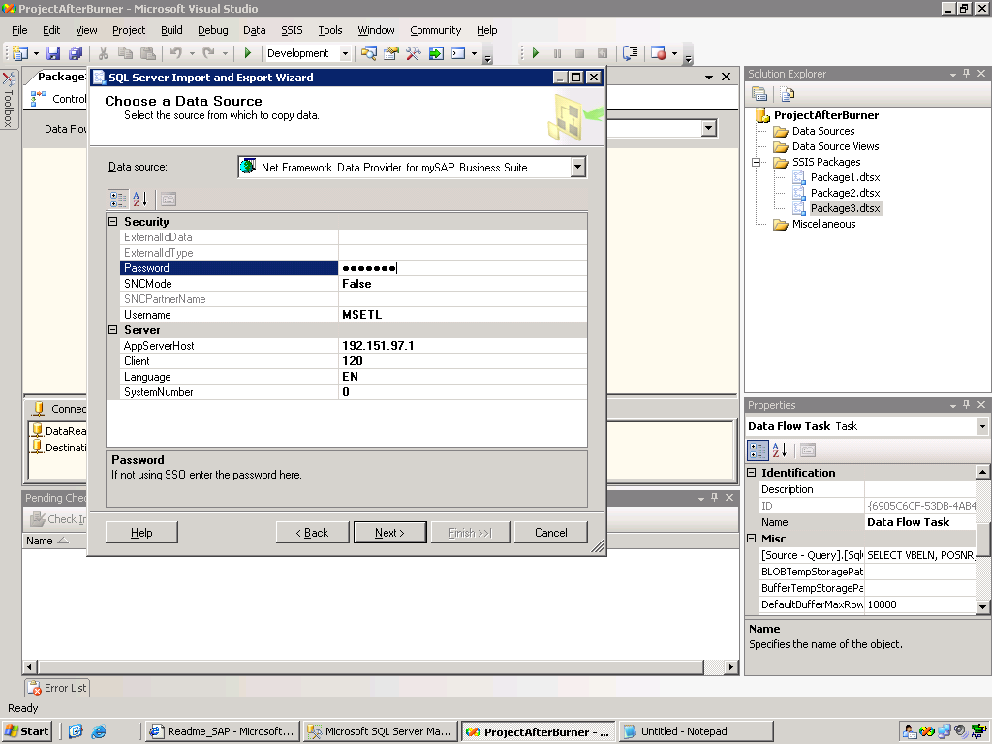

Choose the destination, should be the SQL Repository:
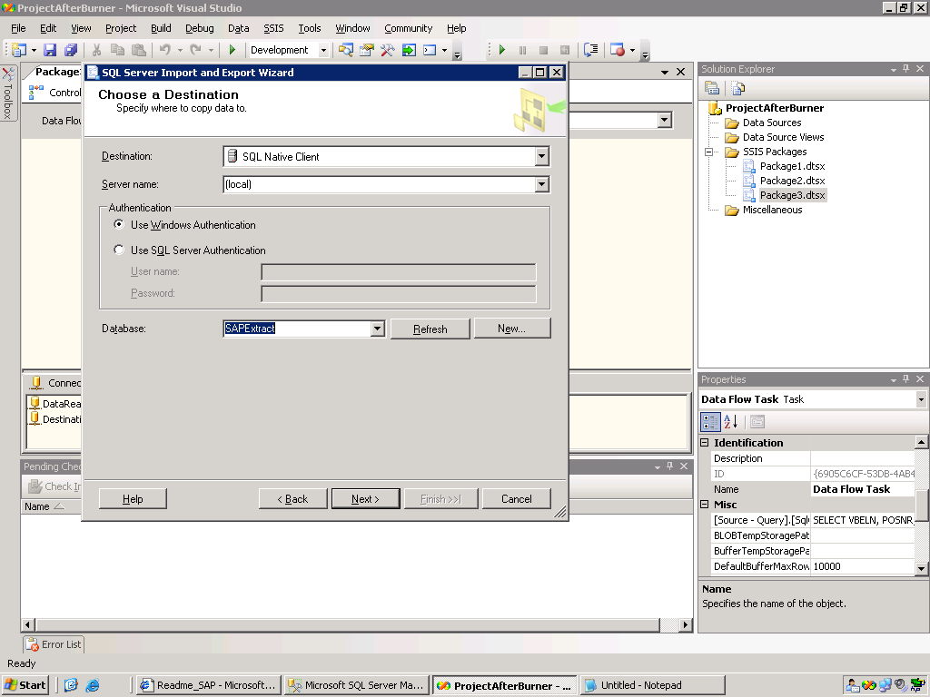

Select Next:
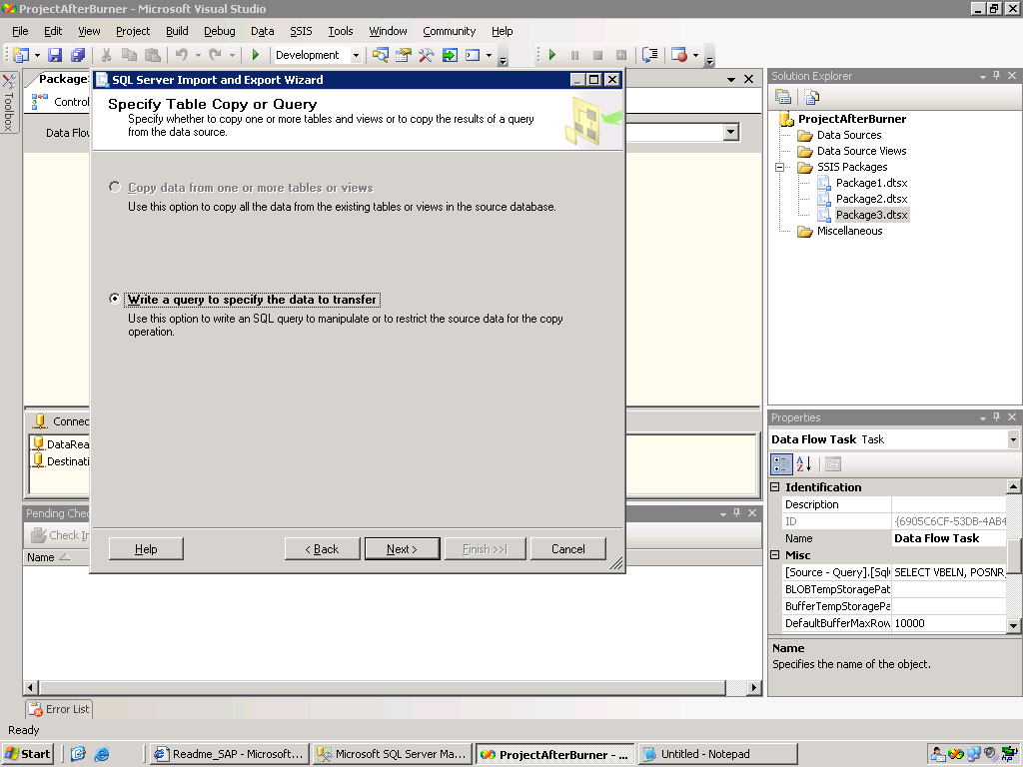

Enter your BAPI, RFC, or SQL like query:
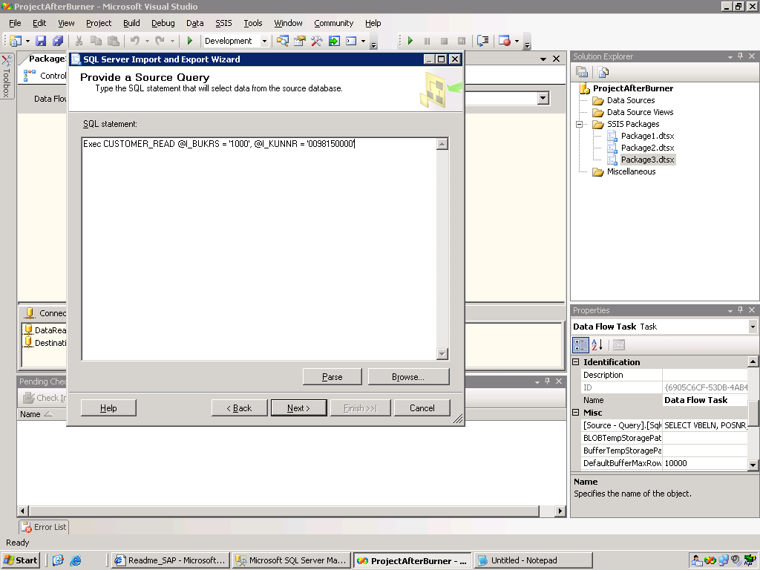

Select a destination table:
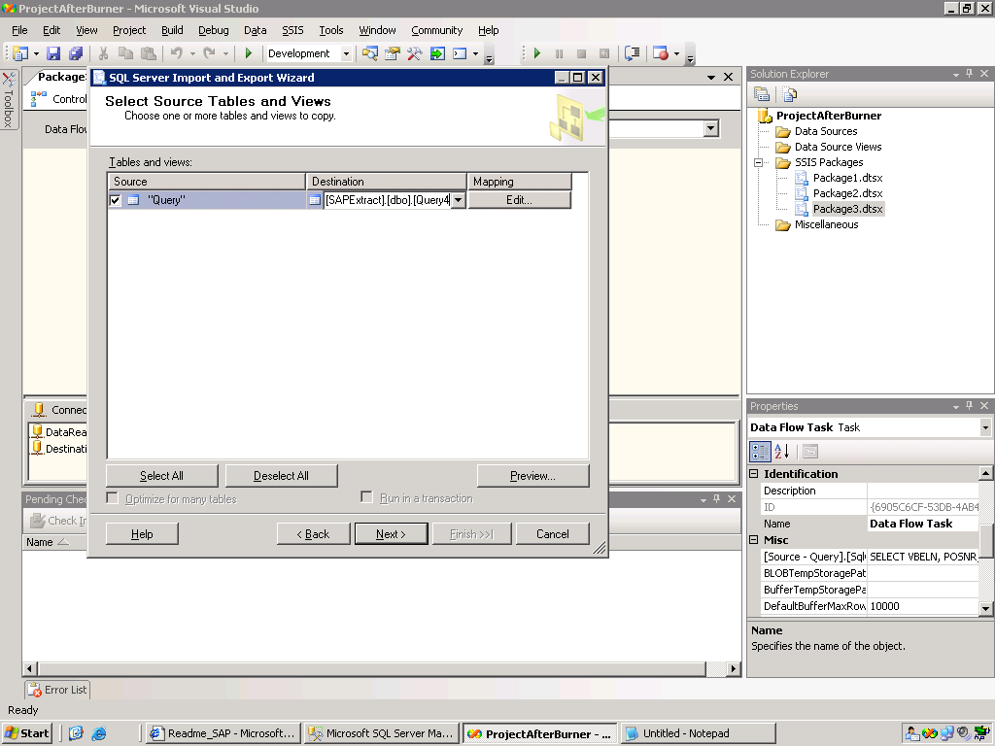

Click Edit and set your column mappings for the query:
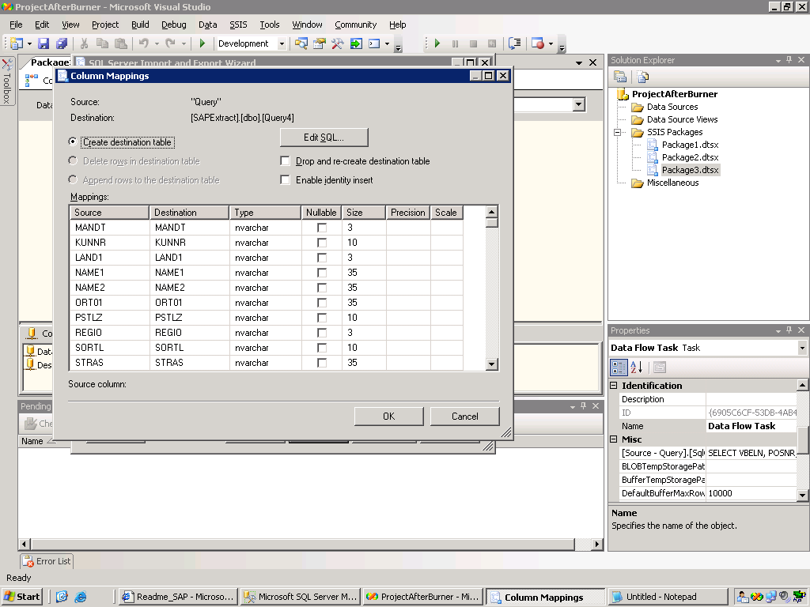

Run the package:
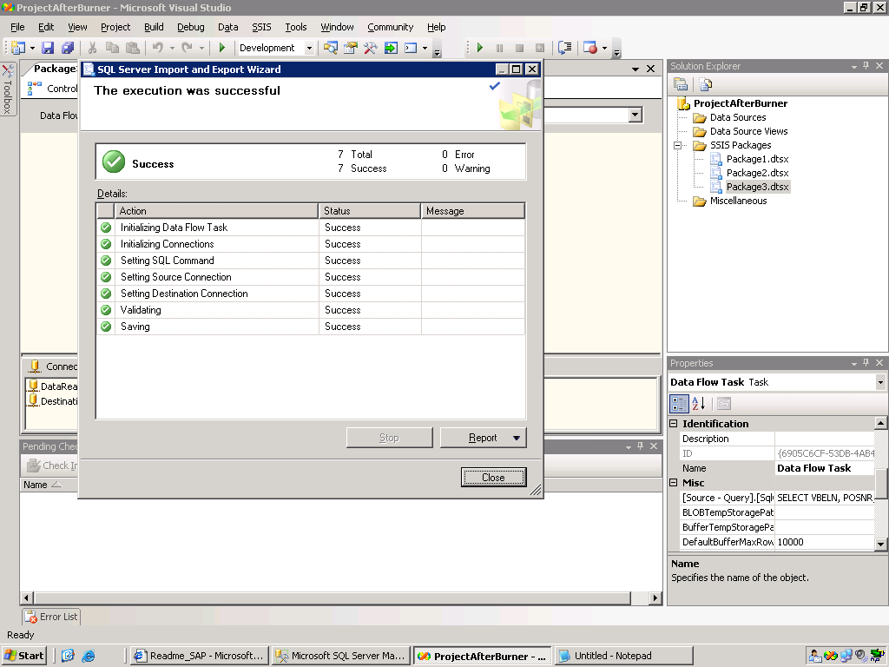

Data exported to SQL Server:
