USING THE SAP .NET CONNECTOR(Version 1.0.3)
Prepared by: Jay Kladiva version 1.0

COMMUNICATION MECHANISMS: RFC, BAPI, IDOC

CURRENT PROJECTS: WMSC Wal-Mart Open Orders, BizTalk OTC-TMS submission of IDOCs to get transaction ID from SAP (TID)

USES: Allows RFC and BAPI calls from .NET applications and can also be used to submit pre-generated IDOCs to SAP

ENVIRONMENTS: Currently the SAP .NET Connector version 1.0.3 is installed on the USHQS055 Web Server, the USHQS093 BizTalk Server, and the USHQS092 BizTalk Server.

NOTES: The SAP .NET Connector must be obtained from the download section of the SAP website. BizTalk 2004 is only compatible with the 1.0.3 version of the SAP .NET Connector, other .NET projects can use newer versions of the SAP .NET Connector. The SAP .NET Connector must be installed on the server that the .NET application will be running on.

IF YOU HAVE QUESTIONS: Contact Jay Kladiva

STEPS TO CALL BAPI OR RFC:

Open Visual Studio.NET 2003 and under C# Projects, select SAP Connector, then select SAP server from the dialog box:
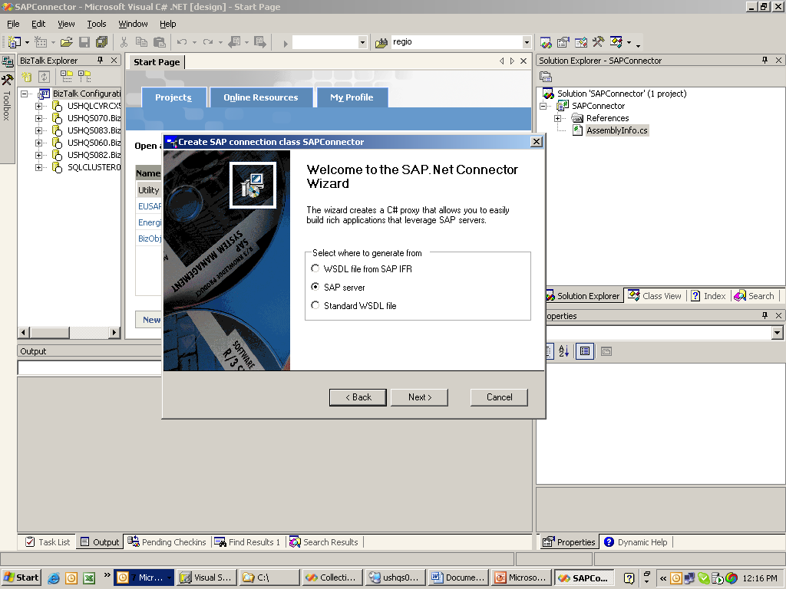

Enter the connection information for SAP and keep the defaults, you want to create a client proxy:
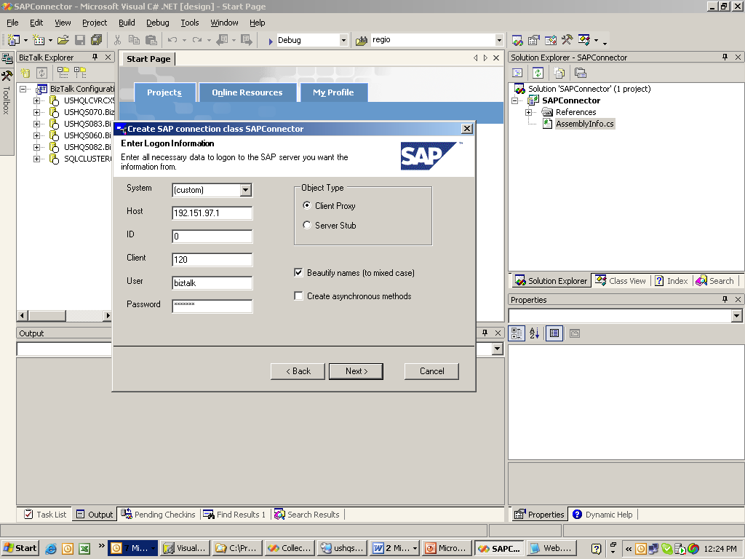

Enter part or all of the name of the RFC you wish to call, then select the RFC you are interested in and click the Add button:
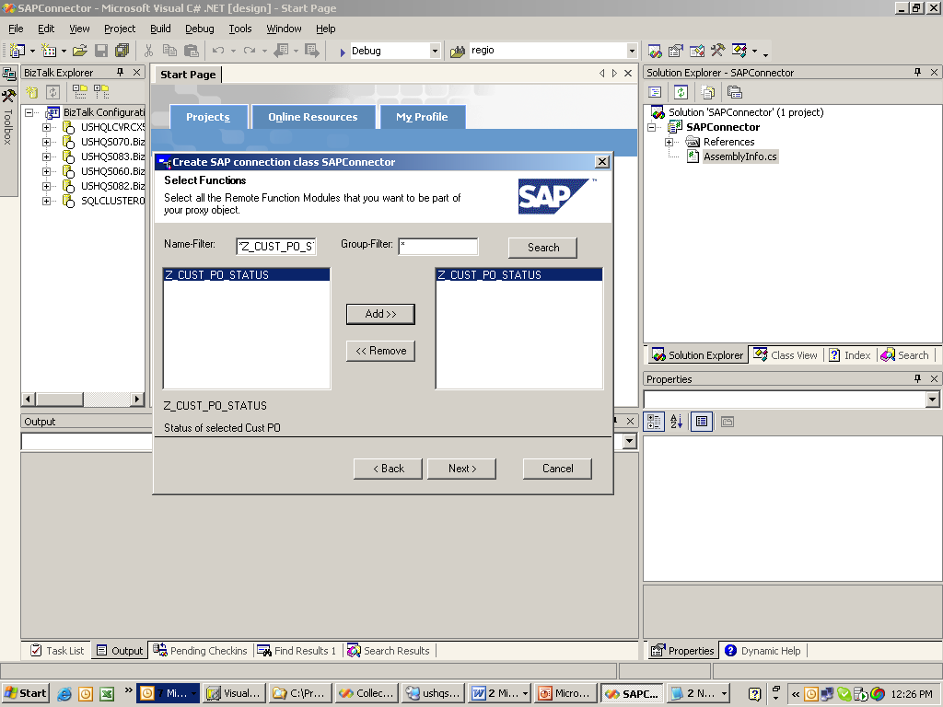

The wizard will create a client proxy which will be utilized to call the RFC:
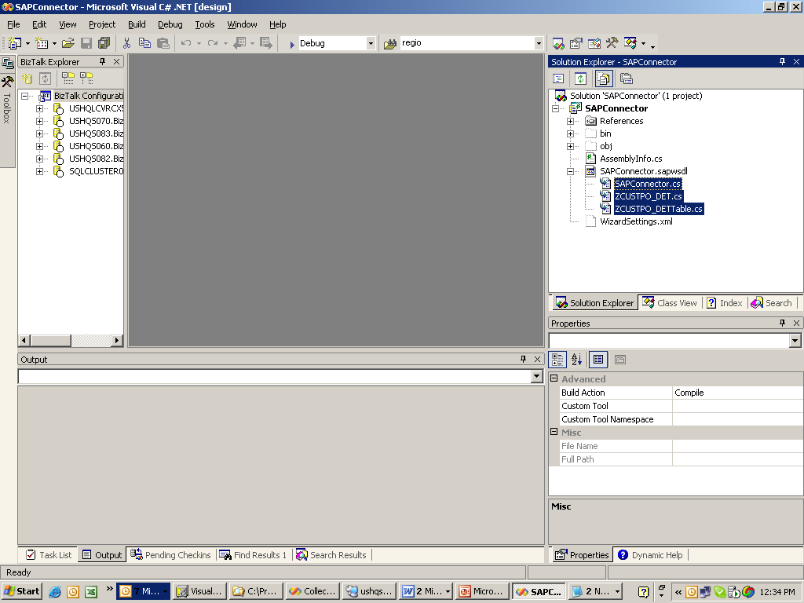

Rename this project with a suitable name and namespace and re-compile the project. This assembly can now be called from one or more .NET projects.

Open your .NET project and set a reference to the assembly that was just created above and also set a reference to Energizer.SAP(this component can be pulled from Visual SourceSafe under the Components directory).

Implement a method which calls the RFC(see code example from WMSC Wal-Mart Open Orders project:

Public Function GetPOData(ByVal partnerNumber As String, ByVal PartnerFunction As String, ByVal orderNumbers() As String) As WMSC.SAP.Data.ZCUSTPO_DETTable

''' This Method is used to get PO Data from SAP. using the SAP Connector
'''

'throw an exception if the partner number is not 10 characters
'should prefix the partner number using "0" (zero)
If partnerNumber.Length <> 10 Then
Throw New WMSCSAPException("Partner Number must be 10 characters")
End If
'Throw an exception if too many orders are passed in
If orderNumbers.Length > MaxPONumbers Then
Throw New WMSCSAPException("Can only pass up to " & MaxPONumbers & " order numbers per call.")
End If

'create an SAP Connection Object
Dim sapDest As New Connector.Destination
sapDest = InitializeConnection()
Dim wmscProxy As New WMSC.SAP.Data.WMSCSAPProxy
wmscProxy.Connection = New Connector.SAPConnection(sapDest)

'create a New DETTable to store the order numbers
Dim orders As New WMSC.SAP.Data.ZCUSTPO_DETTable

'create a variable to be used to add orders into the orders DETTable
Dim order As WMSC.SAP.Data.ZCUSTPO_DET

'loop through each order passed for our orderNumbers parameter
For Each strOrder As String In orderNumbers

'make sure the order number is not blank
If Not Trim(strOrder) = "" Then

'create a new instance of DET
order = New WMSC.SAP.Data.ZCUSTPO_DET

'Define the PO Number
order.Cust_Po = strOrder

'add to the orders table
orders.Add(order)
End If
Next
'create a new instance of DETTable to retain our results from the RFC
Dim results As New WMSC.SAP.Data.ZCUSTPO_DETTable

'create a string to pass in another required byref parameter for this RFC
Dim returncd As String

'open the connection
wmscProxy.Connection.Open()

'call the function
wmscProxy.Z_Cust_Po_Status("", partnerNumber, PartnerFunction, returncd, orders, results)

'close the connection
wmscProxy.Connection.Close()

'return the results
Return results
End Function

STEPS TO SUBMIT IDOC:

The SAP .NET Connector can be utilized to submit IDOCs from any .NET application. We currently utilize this in BizTalk to get a transaction ID from SAP(TID) from a given IDOC submission.

BizTalk Function call to custom method we created:
TID = SAPConnectorObj.SubmitIDOC(SAPHost, SAPClient, SAPSystemNumber, SAPUserName, SAPPassword, IDOCFilePath);

Custom class we implemented:
Public Class IDOCSubmit

'// We call this method to submit the Idoc and return the TID value. We need to pass in all the
'// SAP communication information in order for this to occur. The returned value is the string
'// TID.
Public Function SubmitIDOC(ByVal Host As String, ByVal Client As Int32, ByVal SystemNumber As Int32, _
ByVal User As String, ByVal Password As String, ByVal IDOCPath As String) As String

Dim tid As New SAP.Connector.RfcTID(System.Guid.NewGuid())
Dim sapConnection As SAP.Connector.Destination
Dim docSender As New SAP.Connector.SAPIDocSender
Dim iCount As Int32 = 0

Try
'// we needed to write in this delay loop because we were frequently trying to
'// submit the Idoc before it was written to file by the send from the orchestration.
Do While Not System.IO.File.Exists(IDOCPath)
If iCount < 2 Then
System.Threading.Thread.CurrentThread.Sleep(1000)
Else
Throw New ApplicationException("Unable to locate the IDOC file: " & IDOCPath)
End If
iCount += 1
Loop

sapConnection = InitializeConnection(Host, Client, SystemNumber, User, Password)
docSender.Connection = New SAP.Connector.SAPConnection(sapConnection)
docSender.SubmitIDoc(IDOCPath, tid)
docSender.ConfirmTID(tid)
Catch sapEx As SAP.Connector.RfcCommunicationException
Throw New ApplicationException("SAP Communication Exception: " + sapEx.Message)
Catch sapRfcEx As SAP.Connector.RfcException
Throw New ApplicationException("SAP Rfc Exception: " + sapRfcEx.Message)
Catch ioEx As IO.IOException
'// this can happen if the BTS process has not released the file
Dim msg As String = ioEx.Message
Throw New ApplicationException("Error accessing file " + IDOCPath + ". Error message: " + msg, ioEx)
Catch ex As Exception
Throw New ApplicationException("Unexpected Error: " + ex.Message, ex)
Finally
If Not docSender Is Nothing Then docSender.Dispose()
If Not sapConnection Is Nothing Then sapConnection.Dispose()
End Try

Return tid.ToString().Substring(0, 24)

End Function

'// This method creates a new Destination object which is used to establish the connection to
'// the target SAP system.
Private Function InitializeConnection(ByVal Host As String, ByVal Client As Int32, ByVal SystemNumber As Int32, _
ByVal User As String, ByVal Password As String) As SAP.Connector.Destination

Dim sapConnection As SAP.Connector.Destination
' initialize the connection
sapConnection = New SAP.Connector.Destination
sapConnection.AppServerHost = Host
sapConnection.Client = Client
sapConnection.Password = Password
sapConnection.Username = User
sapConnection.SystemNumber = SystemNumber

Return sapConnection
End Function
End Class

BizTalk Orchestration that utilizes the SAP .NET Connector:
